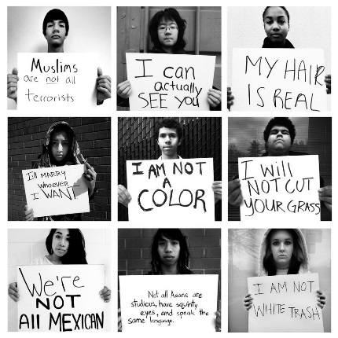
Fifty shades of gay
by iO Tillett Wright
TED Talk Women 2012
Intro: Human beings start putting each other into boxes the second that they see each other -- Is that person dangerous? Are they attractive? Are they a potential mate? Are they a potential networking opportunity? We do this little interrogation when we meet people to make a mental resume for them. What's your name? Where are you from? How old are you? What do you do? Then we get more personal with it. Have you ever had any diseases? Have you ever been divorced? Does your breath smell bad while you're answering my interrogation right now? What are you into? Who are you into? What gender do you like to sleep with?
I get it. We are neurologically hardwired to seek out people like ourselves. We start forming cliques as soon as we're old enough to know what acceptance feels like. We bond together based on anything that we can -- music preference, race, gender, the block that we grew up on. We seek out environments that reinforce our personal choices. Sometimes, though, just the question "what do you do?" can feel like somebody's opening a tiny little box and asking you to squeeze yourself inside of it. Because the categories, I've found, are too limiting. The boxes are too narrow. And this can get really dangerous.
[Her background and journey towards a gay identity}
{Questions why gay marriage is even a debate in the USA}
If this was a war with two disparate sides, I, by default, fell on team gay, because I certainly wasn't 100 percent straight. At the time I was just beginning to emerge from this eight-year personal identity crisis zigzag that saw me go from being a boy to being this awkward girl that looked like a boy in girl's clothes to the opposite extreme of this super skimpy, over-compensating, boy-chasing girly-girl to finally just a hesitant exploration of what I actually was, a tomboyish girl who liked both boys and girls depending on the person.
So after traveling and talking to people in places like Oklahoma or small-town Texas, we found evidence that the initial premise was dead on. Visibility really is key. Familiarity really is the gateway drug to empathy. Once an issue pops up in your own backyard or amongst your own family, you're far more likely to explore sympathy for it or explore a new perspective on it. Of course, in my travels I met people who legally divorced their children for being other than straight, but I also met people who were Southern Baptists who switched churches because their child was a lesbian. Sparking empathy had become the backbone of Self Evident Truths.
But here's what I was starting to learn that was really interesting: Self Evident Truths doesn't erase the differences between us. In fact, on the contrary, it highlights them. It presents, not just the complexities found in a procession of different human beings, but the complexities found within each individual person. It wasn't that we had too many boxes, it was that we had too few.
At some point I realized that my mission to photograph "gays" was inherently flawed, because there were a million different shades of gay. Here I was trying to help, and I had perpetuated the very thing I had spent my life trying to avoid -- yet another box. At some point I added a question to the release form that asked people to quantify themselves on a scale of one to 100 percent gay. And I watched so many existential crises unfold in front of me. People didn't know what to do because they had never been presented with the option before. Can you quantify your openness?
Once they got over the shock, though, by and large people opted for somewhere between 70 to 95 percent or the 3 to 20 percent marks. Of course, there were lots of people who opted for a 100 percent one or the other, but I found that a much larger proportion of people identified as something that was much more nuanced. I found that most people fall on a spectrum of what I have come to refer to as "Grey."
Let me be clear though -- and this is very important -- in no way am I saying that preference doesn't exist. And I am not even going to address the issue of choice versus biological imperative, because if any of you happen to be of the belief that sexual orientation is a choice, I invite you to go out and try to be grey. I'll take your picture just for trying. What I am saying though is that human beings are not one-dimensional. The most important thing to take from the percentage system is this: If you have gay people over here and you have straight people over here, and while we recognize that most people identify as somewhere closer to one binary or another, there is this vast spectrum of people that exist in between.
And the reality that this presents is a complicated one. Because, for example, if you pass a law that allows a boss to fire an employee for homosexual behavior, where exactly do you draw the line? Is it over here, by the people who have had one or two heterosexual experiences so far? Or is it over here by the people who have only had one or two homosexual experiences thus far? Where exactly does one become a second-class citizen?
Another interesting thing that I learned from my project and my travels is just what a poor binding agent sexual orientation is. After traveling so much and meeting so many people, let me tell you, there are just as many jerks and sweethearts and Democrats and Republicans and jocks and queens and every other polarization you can possibly think of within the LGBT community as there are within the human race. Aside from the fact that we play with one legal hand tied behind our backs, and once you get past the shared narrative of prejudice and struggle, just being other than straight doesn't necessarily mean that we have anything in common.
So in the endless proliferation of faces that Self Evident Truths is always becoming, as it hopefully appears across more and more platforms, bus shelters, billboards, Facebook pages, screen savers, perhaps in watching this procession of humanity, something interesting and useful will begin to happen. Hopefully these categories, these binaries, these over-simplified boxes will begin to become useless and they'll begin to fall away. Because really, they describe nothing that we see and no one that we know and nothing that we are. What we see are human beings in all their multiplicity. And seeing them makes it harder to deny their humanity. At the very least I hope it makes it harder to deny their human rights.
So is it me particularly that you would choose to deny the right to housing, the right to adopt children, the right to marriage, the freedom to shop here, live here, buy here? Am I the one that you choose to disown as your child or your brother or your sister or your mother or your father, your neighbor, your cousin, your uncle, the president, your police woman or the fireman? It's too late. Because I already am all of those things. We already are all of those things, and we always have been. So please don't greet us as strangers, greet us as your fellow human beings, period.
Questions: Answer the questions below in detail.
- What are the conflicts that the LGBTQ community face?
- How has her project to photograph LGBQ people changed her way of thinking?
- What does she mean by "50 shades of gay"?
- How would her “moral universe” affect her attitude towards LGBTQ rights?

