Narrative Essay
A narrative essay is a story written about a personal experience. Writing a narrative essay provides an opportunity to get to know and understand yourself better. One of the best ways to reveal who you are is to write about how you became aware of something, gained a new way of seeing the world, a new insight.
Write a narrative essay on ONE of the ideas taken from the First People’s Principles of Learning:
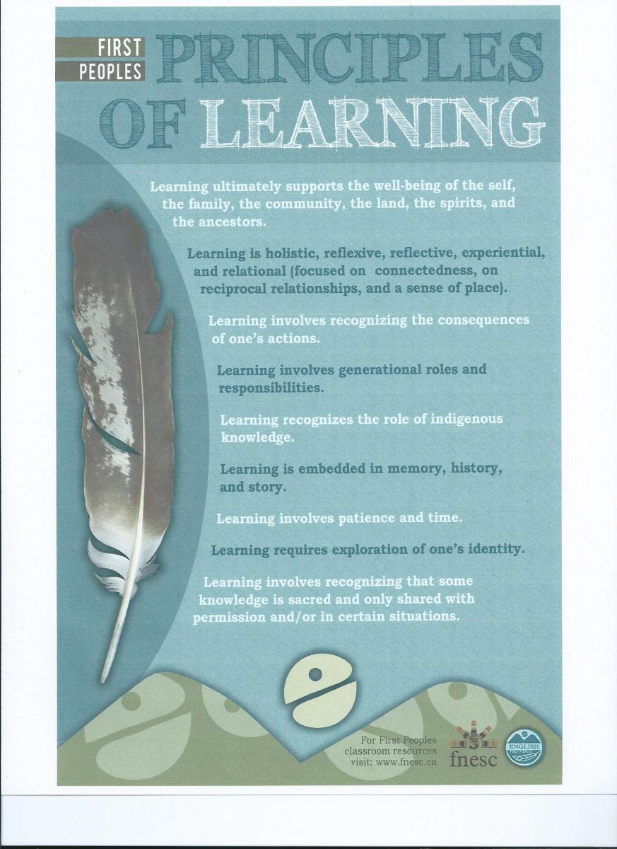

Elements of a personal essay
- Central theme: This is the main point or idea behind the narrative. The narrative may be about a unique event, but the theme is a universal truth to which anyone can relate that informs the narrative.
- Epiphany: An epiphany is a moment of sudden realization or awareness of the truth. As “aha” moment in the essay. A personal narrative may contain multiple epiphanies in varying degrees.
- Suspense: Try to write in a way that keeps your reader wanting to know what will happen next. If your readers already know how everything is going to turn out in the first paragraph, why should they continue?
- Climax: As with fiction, a personal narrative works towards a climactic event, a turning point, or moment of action to which the narrative builds. This is the highest point of tension in an essay. Sometimes the climax can also result in a moment of epiphany.
- Self-honesty: Effective personal essays will reveal moments of vulnerability or weakness. Honesty is key, even if that honesty is revealing or a little hard to admit. Remember, you are in charge of how much you reveal, and you should not violate another person’s privacy by revealing sensitive information.
- Description: Create the sensory images and emotions of your experience so that your reader knows what you saw, felt and thought.
- Character Development: The people in your narrative, especially yourself, need to come alive and seem like the real and interesting people. Using dialogue or mentioning a quirky character trait goes a long way in creating a three-dimensional character. Not every person who shows up in your narrative will require characterization
- Chronological Organization: The organization is chronological, with events occurring in a sequence. Sometimes writers play with time by starting at the end and then backtracking, but some form of time is usually the organizational principal.

Criteria:
1. 1. Between 800-1200 words
2. First or third person perspective
3. Present tense
4. Show don’t tell!!!
5. Must be a real story about you- not fictional! (eg. no aliens or zombies)
6. Must be typed (12 font) and 1.5 spaced
7. Mechanics and Conventions:
- Dialogue punctuated properly
- When using the rule of 3’s, be sure to be parallel.
- Combine your sentences with ;THANO’s’
- No “deadwood”. Prune for a more healthy, full story.
8. Sentence Fluency: A mix of short and long sentences when appropriate.
9. Ideas: Do you have a purpose to your essay and is it clear? Is it a mature subject or a simple subject expressed with mature writing? Look to the inquiry questions on the back board- does your story answer one of the questions?

Narrative Essay Steps
- Look at my powerpoint on the “writing” page on my Edublog
- Read and analyze, “The Boy with Chris Pine Blue Eyes”
- Do the brainstorm below.

Checklist
- What is your purpose? Ask someone to read your essay and get them to tell you the purpose. If they don’t know, you need to add/change/delete to make it clearer.
- Do you have dialogue? Would your narrative be stronger with dialogue? Did you format it correctly? A new paragraph occurs after each speaker. Note where quotation marks occur.
- Have you SHOWN your story- don’t tell. Describe how you feel, what you see, hear, smell, taste.
- Do you begin your narrative IN the action? (much more interesting)
- Are you too wordy? Eliminate any “dead wood”. (How many times has someone told you a story with too many details and you are thinking “get to the point!”

Possible ideas that would work for a narrative essay:
- Inspired by an event
- Losing respect for a family member
- Exploring the outdoors in extreme weather
- Camping stories
- Stories passed on from your family
- Accidents
- Holiday stories (good and bad)
- Losing something
- Hurting someone when you don’t mean to
- A near death experience
- To friend or not to friend
- Boy/girl issues
- My moment as a sports hero
- The day I was a victim of harassment, bullying, discrimination
- The day I realized I was an adult
- The day I was right but my parents/friends were wrong
- The day I realized I like moths
Old government exam topics:
- People learn in a variety of ways.
- Competition is an important part of people’s lives.
- The lesson’s we learn affect our future.

Outline for my narrative essay:
Topic: ________________________________________________
First People’s Principal of Learning Addressed: ____________________________________________________________
Point of view: ___________________ (1st person/3rd person)
First _______________________________________________________________________________________________________________________________________________________________________________________________________________________________________
Then _______________________________________________________________________________________________________________________________________________________________________________________________________________________________________
Then _______________________________________________________________________________________________________________________________________________________________________________________________________________________________________
Finally _______________________________________________________________________________________________________________________________________________________________________________________________________________________________________

The purpose of this narrative is to show your reader _____________________________________

Narrative Essay Rubric
 | 10/9 | 8.5/8/7.5 | 7/6.5 | 6/5
Ideas/Purpose | -A unique story that is shared using details that make the narrative truly memorable  -Purpose is inferred or stated naturally | -An interesting experience is shared with details that help create the interest  -Purpose is inferred or stated clearly | -The interesting experience needs more details  -Purpose is stated explicitly but may not fit the story. OR may be confusing | -The narrative need to focus on one experience. Some details do not fit the narrative or it is missing details  -Purpose is unclear
Organization | The organization makes the narrative easy to read and enjoyable | Organized well with a clear beginning, middle and end | The order of events need to be corrected  Transitions may be weak or missing | Organization is confusing. Transitions weak or missing
Voice | The voice creates an unforgettable experience | The personal voice creates interest. Possibly more dialogue is needed | The voice can usually be heard but may be a bit flat | Voice is simple
Word choice | Exceptional word choice  The story is shown in vivid details and imagery  Shown NOT told | Specific nouns, strong verbs and well-chosen modifiers create vivid pictures and express clear feelings. Some showing as opposed to telling | Some vivid language is used but may be overused or simple.  Story is told, not shown | Little or no attempt at vivid language is used.  Story is told, not shown
Sentence Fluency | The sentences are skillfully written, varied, original and interesting  Effort to combine sentences is obvious. | The sentences show variety and are easy to read and understand  Some effort to combine sentences correctly | More variety in sentences are needed. Sentences may be awkward.  Combining sentences needs to be improved | Too many awkward sentences that cause the reader to pause  Combining sentences needs to be improved
Conventions | Grammar and punctuation are correct (esp. dialogue, and parallelism, commas)  -Present tense | The narrative has a few errors in punctuation, spelling or grammar  -present tense | The narrative has obvious errors in punctuation, spelling and grammar.  -not in present tense | Too many errors in spelling, punctuation and grammar  -not in present tense

