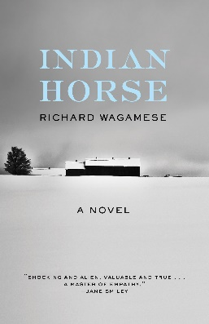
Indian Horse by Richard Wagamese – Unit Summary

End Goal
Approximate due date is April 30th

Answer any of the following questions about the human condition…
- What are the effects of racism on a person/culture?
- How does one build resiliency?
- What is homelessness and how do people get there?
- What is the relationship between the land and the First Peoples of Canada?
- What is the legacy of the Residential Schools on the First Peoples of Canada?
- Ice hockey is considered Canada’s national sport. How did it impact the First Nation’s people?

…in a form of your choosing. Suggestions are as follows:

- Mind map
- Podcast
- Essay (persuasive or expository)
- Infographic
- Narrative
- Spoken word/speech
- Video
- Visual representation of your choice (collage, photo essay, painting)
- Research project using outside sources
- TV talk show interview

Requirements:
Find at least two other sources that explore your question. They can be fiction or non-fiction. Choose wisely! We will discuss what this looks like as we read.
As we read, record notes on OneNote in the “Inquiry” section. Collect quotes, evidence, outside sources (be sure to collect citations as well)

Skills and Knowledge needed to get to this end goal

Literature Concepts:
- Characterization-
  - Direct and Indirect
  - Using characterization to illuminate theme for self- reflection
- Imagery
  - Wagamese uses imagery of a nature to highlight emotions and theme. Why nature? Note when he creates beautiful images and when he purposely uses stark, brutal images. How does this illuminate the theme? How does this connect to the First Nation’s identity and principles of learning?
- Vocabulary- create a logophile (a collection of words) from the book to increase your vocabulary.

Reading Strategies
- Connection (Text to self/text/world)
- Questioning
- Inferring
- Transformation
- Visualization

Assignments- we will do some, but not all, of these assignments.
- Background information- group power point /10 marks
- OneNote comprehension questions /completion marks
- OneNote characterization chart and paragraph /completion marks
- OneNote imagery quote collection /completion marks
- Logophile (mid book) /10 marks
- Reading quiz covering plot, characterization and imagery /15-20 marks
- Partner reading and podcast discussion /5 marks
- Informal and formal blog reflections (Eg. Is Canada racist?) /5 marks
- Tableaus
- Narrative Essay /20-30 marks
- Final project – see above /30 marks
- One of /10 marks
  - Challenging bias on homelessness
  - Analyzing our connection to the natural world
  - Sense of place and identity

