This Little Bin Is Big on Memories and Delish Dishes.
Bin 941 is one of the smallest restaurants in downtown Vancouver but packs a big punch when it comes to flavour and memories. The atmosphere has a funky, eclectic vibe with art that makes the thoughts stumble. Once ushered through the glass doors, the friendly chefs call out an enthusiastic greeting over the sizzling pans. My nose twitches with the scent of red meat and red wine as the cute bartender smiles a hello over the counter. The metallic chairs are hard on the toush and there is little room for elbows but the inhaling of breath to make room is worth it for the food. MMMM, the flank steak with gooey maple syrup drizzled over the shoe string fries is a consistent favourite. The fresh, local mussels in a creamy Thai coconut broth requires triple orders of their Navaho pan bread for dipping. Even with this marvelous menu, nothing beats the cracked vinyl in the front window booth with the view of the street. This is where my future husband asked my father for my hand in marriage. Between morsels of crab cake, my dad happily agreed. How could he not when his future son-in-law was paying the bill? (Which is affordable, by the way- shhh). This Bin may be small but the memories and the food are huge.
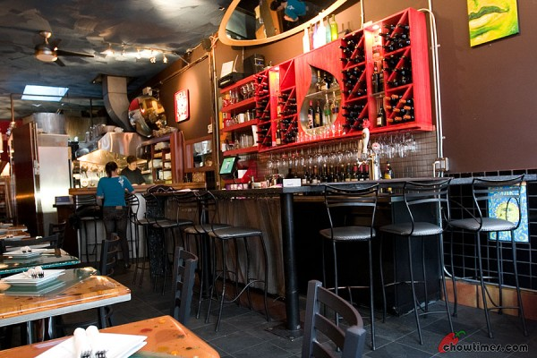
https://chowtimes.files.wordpress.com/2009/10/bin-941-tapas-parlour-20-600x400.jpg

