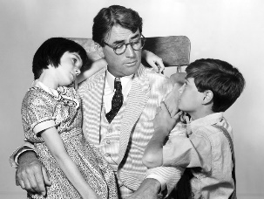
Tableau- Dynamic Character Development in TKAM
A tableau is where a group of people freeze into a scene, using their facial expressions and bodies to show meaning.
In this case, you are to also add ONE word that boils down the whole scene.

- In groups of four-five students, show the growth of Atticus, Jem or Scout, depending on your stickies. In which scenes did they show they had matured? Which experiences and people had the most impact on their lives?

- Reduce the story into FIVE main plot points in the novel and ONE word per scene. These scenes will show the growth of the characters. Remember, only five plot points so make it count!

- In your group, decide how you are to show these five points. EVERY STUDENT MUST PARTICIPATE IN EVERY SCENE.

Assessment:
-accuracy of scene selection. Does it reflect growth? /2.5
-appropriateness of ONE word per scene /2.5
-group dynamics (is everyone involved in the scene?) /1

