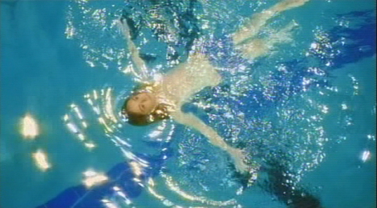
No Bikini: A Short Story
Ivan Coyote was born and raised in Whitehorse, Yukon Territory. An award-winning author of eight collections of short stories, one novel, three CD’s, four short films and a renowned performer, Ivan’s first love is live storytelling, and over the last nineteen years they have become an audience favourite at music, poetry, spoken word and writer’s festivals from Anchorage to Amsterdam.
Pre-discussion/prewriting:
- How important is gender expression (male vs female) to children? What role do parents have in allowing a child to express their gender identity?
OR
- Are some kinds of spaces in our society more gendered than others? For example, a swimming pool compared to a grocery store? Explain what makes these spaces gendered or not.

Writing Analysis:
- Circle all the short, declarative sentences. What is the purpose of using this writing style in these places? Answer in a short sentence or two.
- Why do you think she begins the story with “I had a sex change once, when I was six years old?” What do you think his purpose was for beginning like this?
- Find the rule of 3’s. Underline them.
- Find an example of the use of a colon. Circle it. What rule is applied to this use?
Questions:
Text driven questions to help understand the story on a surface level:
- Why did the protagonist not wear the top of their bathing suit?

- How did the main character feel when they were thought to be a boy during the swimming lessons?

- Why does the protagonist not correct the swimming teacher?

- What does the protagonist notice about the difference between being perceived as a girl versus a boy?

Deeper questions that extend understanding:
- What is the point of view? Omniscient, limited omniscient, first person or objective? Why do you think Coyote uses this particular one?

- Why did the swimming teacher not question the protagonist’s gender? What does this imply about gender expression?

- What is the central conflict of the story? How is the family affected by the conflict? How is the conflict resolved?

- What do you think they mean when they say, “And that I had never, not once, felt naked”.

- Is the protagonist a dynamic or static character? Explain.

- Theme statement: (Topic + treatment +/- = result)

Post-writing:
How is gender identity and expression influenced by societal expectations? Use examples from real life.
OR
Do you have a personal connection to this story? Have you experienced or know someone who has experienced a “crisis” in their gender identity?

