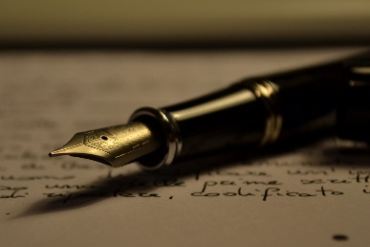
Compare and Contrast Essay- Assignment
In English writing and analysis, compare and contrast involves taking two pieces of media and finding similarities and differences between them. Usually, the comparasion surrounds a theme (for example, culture, loss, genocide, revenge, hatred, etc.) By putting the two pieces together and looking for similarities and differences, we whould be able to get new insights.
Criteria:
- 1200-1700 words (4-5 paragraphs)
- 1.5 spaced, 12 font
- Formal essay (no “I” “you” or contractions)
- Present tense when analyzing literature
Due on Friday, December 21st, printed.
Here are the steps to creating your own compare and contrast essay:
- Start with a question and two sources. Choose one:

- What has influenced the First Nation’s cultural identity? (“Sorry for Not Being A Stereotype”,” Knock Off Native”, “Totem”)
- Which source best explains “What it feels like to be …” (“No Bikini”, “What it feels like…”, 50 Shades of Gay OR “What Kind of Asian Are You”, Homecoming King, Kim’s Convenience OR “Knock Off Native”, “Sorry for Not Being a Stereotype”)
- What conflicts may arise when one has a minority identity? (“No Bikini”, “What it feels like…”, “50 Shades of Gay”, OR “Knock off Native”, “Sorry For Not Being… “,”Totem” OR “What Kind of Asian”, Homecoming King)
- How do stereotypes affect a culture/person? (Any of the spoken word poems, “50 Shades of Gay”, Homecoming King, “Sorry For Not Being a Stereotype”)
- Your choice. Check with me first.

- Brainstorm: Use a Venn Diagram OR a Chart to find the similarities and differences. You can compare and contrast the following:
  - Answer to the question
  - Structure
  - Message/theme
  - Characters
  - Other

- Thesis: Answer the question with your pieces of literature. The answer to your inquiry quesition is your argument..
  - Eg.

- Collect evidence from the text that support your argument and use quotes. Use the graphic organizer given to you.

- Check the rubric. Are you aware of the criteria? The expectations?

- Write the essay:
- 1.5 spacing 12 font
- 1200-1700 words MAX (trim the “deadwood” if too much)
- No “you” or “I”
- Present tense
- Format your quotes properly with MLA formatting (I will show you)
- I will be looking at your use of all grammar we have learned in class
- You will have three days of lessons and to fill in an outline. The outline can be done for homework as well as in-class.
- You must have your outline checked before you can begin your essay.
- We will spend three days in class writing. IT IS NOT TO BE TAKEN HOME. It is an “in-class essay”

- Revise for mechanics and grammar. Highlight the thesis and transition words

