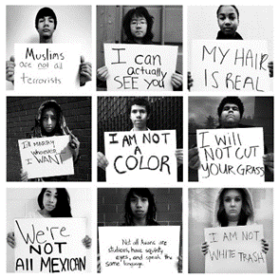
50 Shades of Gay
by iO Tillett Wright
TED Talk Women 2012
Questions: Answer the questions below in detail.
- What are the conflicts that the LGBTQ community face?
- How has her project to photograph LGBQ people changed her way of thinking?
- What does she mean by the title "50 shades of gay"?
- How would her “moral universe” affect her attitude towards LGBTQ rights?

