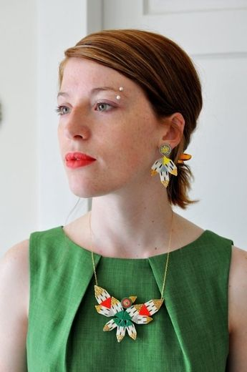
“Knock Off Native” by Winona Linn

He came to me after the show and called me a “Knock off Pocahontas”
I told him if he really wanted to insult me accurately, he should have at least picked the right race
Pocahontas was Pohatan and I am Meskwaki
But I knew he would not know the difference

I wanted to tell him Pocahontas was more than a pictorial Disney character that sang to animals while she braided her hair
But if he really wanted to shame to for not living up to my ancestors he should have used the name “Keokuk” or Black Hawk or Wapello the Prince
But I knew that his ______ brain would not know those names
He wanted him to ask me where my feather was or that my $15 calfskin moccasins didn’t make me Native, but he wasn’t creative enough for that
He could only call me out because of the colour of my skin but my skin doesn’t match his perception of Indian
And my hair was only black in my emo phase in high school
It was never highlighted with the colours of the wind… or whatever

I wanted to tell him he should have offered me firewater
so I could have thrown it in his face and watered down this fire that climbs up this unkept English ivy that climbs up my throat to burn my teeth, my tongue spits fire like tomahawks sharpened on redstone at midnight

I wanted to tell him
I know my hair is red, but I’ve never really had a problem with it because it just makes sense because my blood is too.

I wanted to tell him that the Meskwaki are the people of the red earth
The people that were here first and we understand thirst
And not just because not one Canadian reserve has drinkable water
But because they thirst for the earth
And when the _______ cursed they never put the earth first

And I wanted to tell him
That Columbus Day celebrates murder
And he could have asked anyone descended from the Tiano people
Of Puerto Rico how it feels to have as your mother tongue the language of the soldiers who raped your grandmothers

I wanted to tell him
That no matter how many times he has relocated his life, he has no idea what it means to move
Be moved
Like we were moved
From the fertile valleys and the technicolor beaches of the Ottawa River
From the pink granite mountains of the Canadian Shield studded with red and white pines stretching up to the sky like the long limber fingers of giants
Jack pines clinging their twisted roots around boulders going South
My brother, South
My sister, South
To the deserts and wind swept yellow plains

I wanted to tell him
That the Meskwaki lived without reservations
Because we don’t live on reservations
8000 acres of Iowa soil bought legally
Like pulling American teeth, we settled on settlements

And I wanted to tell him
That owning our own land means so much more to my people than it does to him because we can’t _____ our own land, our homeland
Because it is all buried under Toronto stone

And I wanted to tell him it is hard to go home when your home is made from broken bones
He called me a “Knock off Pocahontas” and I wanted to tell him
That it is people like him who made me walk across shards of glass as a child
To I could cut my feet so badly that I could finally leave red footprints
Look Ma, no white
People like him who made the suicide stats skyrocket so much that every Canadian reserve has a separate cemetery for children
And I wanted to tell him to shut the f*&@ up
That this _____ babe can freestyle his ass back to Scarborough Ontario

And I wanted to tell him that Pocahontas had never really been one of my heroes, but just because although she has her own Barbie doll,
She didn’t do much more than contact tuberculosis after being kidnapped

I wanted to tell him that I am many Native heroes and Meskwaki women are beautiful
Although I don’t look like my grandmother, I look like my grandmother
He came up to me after the show and called me a “Knock off Pocahontas”
And I wanted to tell him that in order to have his insults gain weight, he should have picked someone with low self-esteem,
Because I have been told since birth that I am a white skinned, green eyed, red-blooded Meskwaki,
a princess
The daughter of the red earth, dotted with freckles and red hair
My self-worth can’t be determined by the words of drunken racists

- How does the author feel about not “looking” Native?

- How do stereotypes affect Winona’s aboriginal identity?

- What is the tone of this poem? Explain.

- This is an example of a political spoken word. Why would it be effective as a means of expressing one’s ideas?

