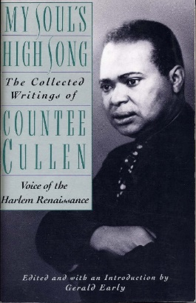
Yet Do I Marvel - Poem by Countee Cullen
I doubt not God is good, well-meaning, kind
And did He stoop to quibble could tell why
The little buried mole continues blind,
Why flesh that mirrors Him must some day die,
Make plain the reason tortured Tantalus
Is baited by the fickle fruit, declare
If merely brute caprice dooms Sisyphus
To struggle up a never-ending stair.
Inscrutable His ways are, and immune
To catechism by a mind too strewn
With petty cares to slightly understand
What awful brain compels His awful hand.
Yet do I marvel at this curious thing:
To make a poet black, and bid him sing!

- Read this poem several times: the first for feeling and the second for meaning
- Question as you read! OR define what you already know. Record these questions or comments on the sheet.
- Answer the researchable questions and do a quick google search on the author (eg. Vocab, author)
- Read for a third time, looking for a deeper understanding by summarizing in your own words line by line or stanza by stanza
- Read for lyrical poetic devices: consonance, assonance, alliteration, rhyme scheme, rhythm.
- Read for ‘word play’: allusions, metaphor, paradox

Structure:
Mood:
Tone:

- Summary and purpose:

- How does withholding the speaker’s race affect the poem?

- What is the significance and the effect of the mythological allusions to the meaning of the poem?

- What is the theme of this poem?

