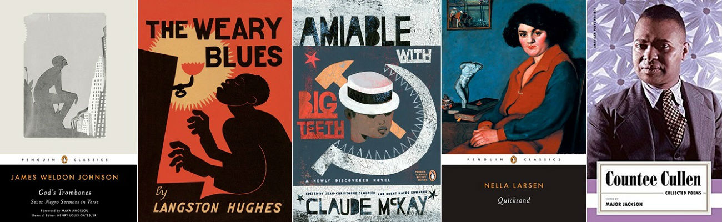
Questions for “The Harlem Renaissance”
- After you have read the article, explain in your own words the meaning of Langston Hughes quote:

- When did the Harlem Renaissance start and when did it “end”?

- Why did it start?

- What was it??

- What effect do you think this Renaissance had in respect to alleviating discrimination during this time frame?