Harlem: A Dream Deferred
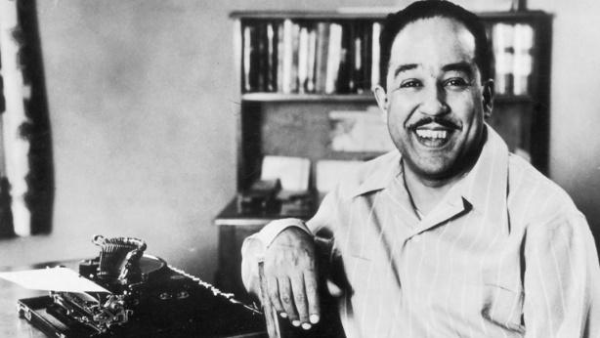
BY LANGSTON HUGHES
What happens to a dream deferred?

Does it dry up
like a raisin in the sun?
Or fester like a sore—
And then run?
Does it stink like rotten meat?
Or crust and sugar over—
like a syrupy sweet?

Maybe it just sags
like a heavy load.

Or does it explode?

Langston Hughes, “Harlem” from Collected Poems. Copyright © 1994 by The Estate of Langston Hughes. Reprinted with the permission of Harold Ober Associates Incorporated.
Source: Selected Poems of Langston Hughes (Random House Inc., 1990)

- Identify the use of imagery for all five senses.
- Label the poetic devices
- What is the tone of the poem?
- How does the sum of all the imagery add up to answering the question put forth by the speaker?
- Can you connect the final line to events happening today?

