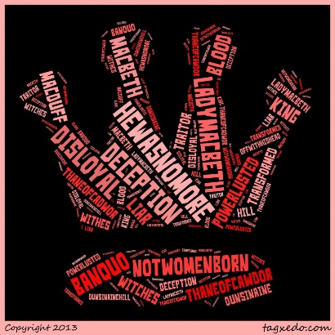
Macbeth Act 3, scene 1-2
Setting the stage- Macbeth is now king of Scotland. In Scottish history, the real King Macbeth ruled from 1040-1057. For 10 years, Macbeth was a fairly good monarch. But in the last seven years of his rule, he became suspicious and cruel.
For the murder plot in the play, Shakesperare borrowed from another time in history. He used historical facts to make his play exciting and to please King James. But he changed history to suit his purposes.
- Find words spoken by Banquo that shows he is suspicious of Macbeth. Write them on the line ________________________________________________________________________________________________________________________________________________
- Why does Macbeth fear Banquo? ________________________________________________________________________________________________________________________________________________
- Explain why Macbeth says the witches put “a sterile crown my head and a barren scepter in my fist” ________________________________________________________________________________________________________________________________________________
- Macbeth is a tragic hero so although he is looking pretty bad right now, he has some strengths as well as weaknesses. List 2 strengths and 2 weaknesses.
Strengths Weaknesses

Scene ii
- What advice does Lady Macbeth give her husband? ________________________________________________________________________________________________________________________________________________________________________
- What does Macbeth NOT tell her? ________________________________________________________________________________________________________________________________________________

- What is the mood of this scene? Find quotes that illustrate this. Explain WHY these quotes create the said mood: ____________________________________________________________________________________________________________________________________________________________________________________________________________________________________________________________

- What do you think is the greatest threat to the Macbeth marriage? Base this opinion on your own experiences and the play. Write a short paragraph explaining your answer.

Famous quotes:
Lady Macbeth: Nought’s had, all’s spent, /Where our desire is got without content: /Tis safer to be that which we destroy /Than by destruction dwell in doubtful joy. (III. ii, 4-7) __________________________________________________________________________________________________________________________________________________________________________________________________________________________________________

