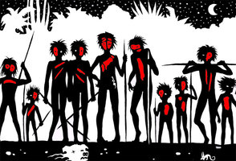
Some of the Big Ideas in Lord of the Flies
- Order vs chaos
- Civilization vs savagery
- Leadership – to be feared or loved?
- Effect of fear
Directions: Find examples (and quotes) that support the following BIG Ideas
Order vs Chaos | Civilization vs Savagery | Leadership styles | The effect of fear
-“They let the fire out” pg 71  -“Rules,” said Ralph, “you are breaking the rules” pg99 | -Roger aims to miss the Little’un with the nuts | -“I got you meat” said Jack and he flung a piece of meat at Simon. | -

