Possible Projects for Macbeth
- Reanactment
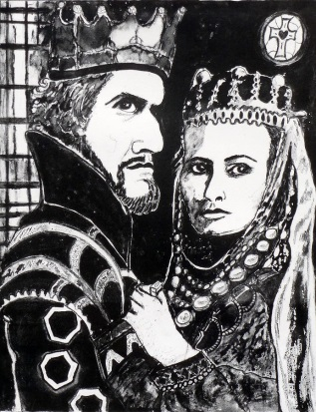
Each group is assigned a scene. You will be acting for 5 minutes.
- Re-enact the most important parts of the act in the following format:
  - Three minutes in Shakespeare language
  - Two minutes in modern English (this can be done as a direct translation OR a modern day translation with slang, etc)
  - One minutes in Shakespeare language

Notes:
    - The scenes do not need to be divided into these parts- you can read half the scene in Shakespeare language and the rest in modern. Use time as your organizer, not the play.
    - Not all lines need to be said. You can take out lines/parts if you don’t deem them necessary.
    - You can make this a modern interpretation or stay true to the original.
- Criteria:
  - A promptbook (see below)
  - Must be acted in class- no videos
  - Costumes and props are encouraged
  - There must be movement!
  - Acting- voice inflection, tone, emotion, pausing, etc.
  - Sound effects- how are you going to show sound? Eg. Running, horses, the bad omens?
- To Do:
  - Promptbook: Each student in your group must have a promptbook. This promptbook will have notes in the margins stating:
    - Actions, exits and entrances using the classroom as your stage.
    - Notes on vocal pauses, stresses and inflections
    - Tone of voice and kind of mood you are looking for
    - Gestures and facial expressions (those that are explicit and implicit)
    - Definitions of words or phrases you do not understand

- Art Project
Using what you know about the characters OR the imagery OR the themes of Macbeth, create an artistic representation of the play. This can be:
- A painting
- A poster
- A diorama
- A collage
- A character study
- Your choice

- An essay
Write a 750-1000 word essay on one of the following:
- The fantastical and grotesque witches are among the most memorable figures in the play. How does Shakespeare characterize the witches? What is their thematic significance?
- Compare and contrast Macbeth, Macduff, and Banquo. How are they alike? How are they different? Is it possible to argue that Macbeth is the play’s villain and Macduff or Banquo its hero, or is the matter more complicated than that?
- Discuss the role that blood plays in Macbeth, particularly immediately following Duncan’s murder and late in the play. What does it symbolize for Macbeth and his wife?
- Discuss Macbeth’s visions and hallucinations. What role do they play in the development of his character?
- Is Macbeth a moral play? Is justice served at the end of the play? Defend your answer.
- Your choice

- Debate
  - Macbeth is responsible for his own downfall.

Everything due by Wednesday, June 17th

