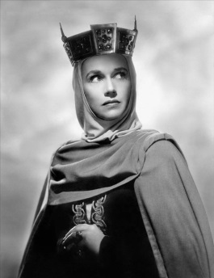
Macbeth- Scene 1.5 Lady Macbeth “Unsex me here!”
Lady Macbeth has received a letter from her husband outlining the witches’ prophecy and his promotion to Thane of Cawdor. She is inflamed by the idea of Macbeth as King and begins to make plans. In early Scotland, men ruled both public and private life. At home too, they controlled their wives and children. Notice that Lady Macbeth wants to “unsex” herself so she can be more like a man.
- Shakespeare often uses images of birds to create a special mood. What bird does he use in this scene? How might the mention of this bird make the audience feel?

- What does she tell her husband to do to prepare for the important business ahead of them?

- Find references to ‘darkness’. Write the lines down. What does it mean?

Famous Quotes- in your own words, explain what this quote means (paraphrase)
Lady Macbeth- “Yet I do fear thy nature; it is too full of the milk of human kindness to catch the nearest way” (line 15-17) ______________________________________________________________________________________________________________________________________________________________________________________________________________________________________________________________________________
“Come you spirits that tend on mortal thoughts! Unsex me here, and fill me from the crown to the toe top full of direst cruelty” (line 40-42) ______________________________________________________________________________________________________________________________________________________________________________________________________________________________________________________________________________
“Look like the time; bear welcome in your eye, Your hand, your tongue: Look like the innocent flower, but be the serpent under ‘t” (line 63-65) ______________________________________________________________________________________________________________________________________________________________________________________________________________________________________________________________________________

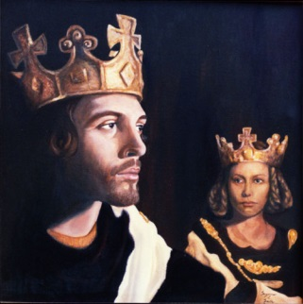
Macbeth- Scene 1.7 “But screw your courage to the sticking place, and we’ll not fail.”
This scene begins outside the banquet hall of Macbeth’s castle. Macbeth has left the dinner that he is giving in honor of the King. He speaks a soliloquy about his fears of murdering King Duncan. Then Lady Macbeth enters the room….
- Macbeth gives several reasons why he shouldn’t kill the King. Name two of the reasons. ________________________________________________________________________________________________________________________________________________________________________
- Lady Macbeth convinces Macbeth to stick to the plans and kill the King. How does she convince him? Give quotes to back up your answer. ________________________________________________________________________________________________________________________________________________________________________________________________________________________________________________________________________________________________________________________________________________
Quotes- put in your own words and explain the meaning
Macbeth “If it were done when ‘tis done, then ‘twere well it were done quickly” (lines 1-3) ____________________________________________________________________________________________________________________________________________________________________________________
Macbeth- “I have no spur to prick the sides of my intent, but only vaulting ambition.” (25-27) ____________________________________________________________________________________________________________________________________________________________________________________
Macbeth- “We will proceed no further in this business” (line 31-32) ____________________________________________________________________________________________________________________________________________________________________________________
Lady Macbeth “We fail? But screw your courage to the sticking-place, and we’ll not fail.” (lines 60-61) ____________________________________________________________________________________________________________________________________________________________________________________
Macbeth “False face must hide what the false heart doth know.” (line 82)
____________________________________________________________________________________________________________________________________________________________________________________

