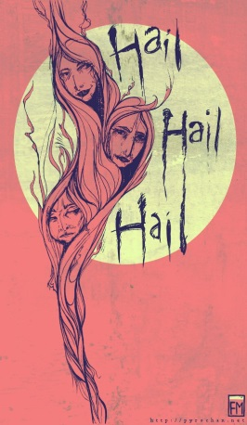
Macbeth- Scene 1.3-1.4 “Is Execution Done on Cawdor?”
Once again, the Weird sisters appear in a deserted field. Macbeth and Banquo will also shortly appear. Apparently, the witches have been waiting for them.
- On the line below, write the first words that Macbeth speaks. __________________________________________________
- You heard similar words spoken earlier in the play. On the line below, tell who spoke those similar words and what did they say? The witches say ________________________________________________________________________________________________________________________________________________________________________________________________________________________
- When Macbeth orders the witches to speak, they address him by three different titles. What are they? ________________________________________________________________________________________________________________________________________________
- Describe Macbeth’s reaction when he first hears the witch’s predictions for his future. ________________________________________________________________________________________________________________________________________________
- Why is Banquo suddenly fearful after Ross’ announcement? ________________________________________________________________________________________________________________________________________________
- Now Macbeth is both frightened and confused because he faces a hard choice. ________________________________________________________________________________________________________________________________________________
Famous Quotes- in your own words, explain what this quote means (paraphrase)
Macbeth- “The Thane of Cawdor lives. Why do you dress me in borrowed robes?” (line 108-110) ____________________________________________________________________________________________________________________________________________________________

Scene 1.4
To the sound of the trumpets, the King, his sons and his nobles enter the castle at Forres.
- Did the Thane of Cawdor die bravely or cowardly? Explain your reasoning. ________________________________________________________________________________________________________________________________________________
- What role does Malcolm (Duncan’s son) play in the future of Scotland?) ________________________________________________________________________________________________________________________________________________
- Macbeth seems upset by the new honors given to Malcolm. Explain what Macbeth means when he says he must “leap over this new step”. ________________________________________________________________________________________________________________________________________________
Quotes- put in your own words and explain the meaning
Duncan- “There’s no art to find the mind’s construction in the face; He was a gentleman on whom I built an absolute trust.” (11-13) ____________________________________________________________________________________________________________________________________________________________
Macbeth- “Stars, hide your fires! Let not light see my black and deep desires” (line 50-51) ___________________________________________________________________________________________________________________________________________________________

