Key Themes in Macbeth
Find quotes OR examples to support these themes:
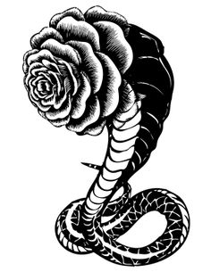
Be sure to include the act, scene and line for each quote.
The effect of guilt on the human mind
Can people take actions they know are wrong and remain unaffected? How are Macbeth and Lady Macbeth changed by their actions? Do they suffer psychologically even when they are not caught? Find quotes or examples that support Shakespeare’s theme that guilt can influence actions.

Appearance vs reality
How can one tell good from evil? Friends from enemies? Why does Duncan think that Macbeth and his wife are trustworthy when they are plotting his overthrow?
Find quotes that reinforce Shakespeare’s theme that appearance can be misleading. Be sure to include who said it.

Greed and power
How do greed and the thirst for power affect Macbeth’s actions? Lady Macbeths? Anyone else? Contrast to Banquo and Macduff. Find quotes and examples that reinforce Shakespeare’s ideas about the effect of greed and power.
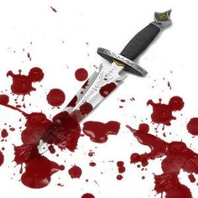
Imagery
Since Shakespeare did not have the special effects technology that we have today, he had to use words and actions to convey mood and imagery. Find quotes that portray each of these key images that Shakespeare was trying to convey. Record the Act, scene and line.
Blood
Darkness and Night
Sorcery and the supernatural
Disorder in nature (thereby symbolizing disorder in the human world)

