READING JOURNAL
Title : Beige
Group members: Mrs. Thomasen, myself and I

Date:  Pages:  Role:  - Research  - Plot  - Character  - Style | TYPE YOUR COMMENTS HERE….ADD IMAGES, MAPS, WHATEVER IS NECESSARY  Include page references  - THE HOUSE:  - 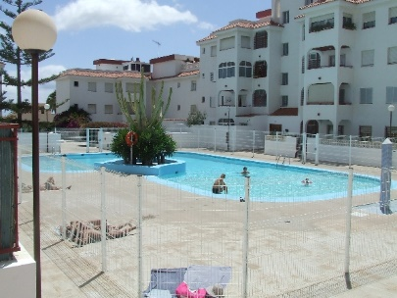  - THE CITY: 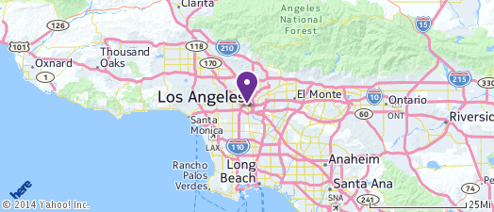  - Discussion question: Do you think Katy will be happy with her Dad? Do you think he is happy to have her here?
Date:  Pages: 1-  Role:  - Research  - Plot  - Character  - Style | Style : pg. 1- « The weather matches my mood, though on the outside I am all clear skies and sunshine. « Metaphor- author uses it to show how she is feeling about her new adventure. She is putting on an act of happiness but inside she is feeling scared and depressed.  Pg. 4 « Someone please throw a pail of water on me so I can melt right into the ground like the Wicked Witch of the West » Imagery and simile. She is so embarassed she just wants to disappear. Interesting reference to Wizard of OZ. Why use this reference?  Pg. 7 « I might not know music, I might not like music, but everyone with half a brain knows the band Suck. They were more like infamous. Infamously un-famous. Infamously messed up. Infamously the greatest band that never made it. » The author writes like she is inside a teenage girls head. She can imagine the repetition, the stress on certain words. You can almost see her rolling her eyes.  The author writes from first person point of view so we can understand Katy’s emotions. The author tries to write like a teenage girl would think or speak. Short sentences, nothing too complex but still appropriate.
Date:  Pages:  Role:  - Research  - Plot  - Character  - Style | - P. 1-3 Katy meets her dad, The Rat, at the LA airport  - P. 5-10- The Rat’s place is disgusting. Katy is very sad to leave  - The author is building tension by having Katy crying in private but putting on a brave face for her dad. We see her very sad to leave her mom.
Date:  Pages:  Role:  - Research  - Plot  - Character  - Style | - Direct characterization- The Rat  - « He was six fee five inches tall and wears a tiny cowboy hat on his head. He’s got a rolled up cigarette hanging from his mouth, and his skinny, sleeve-tattooed arms poke out of his once black, but faded grey t-shirt. »  - 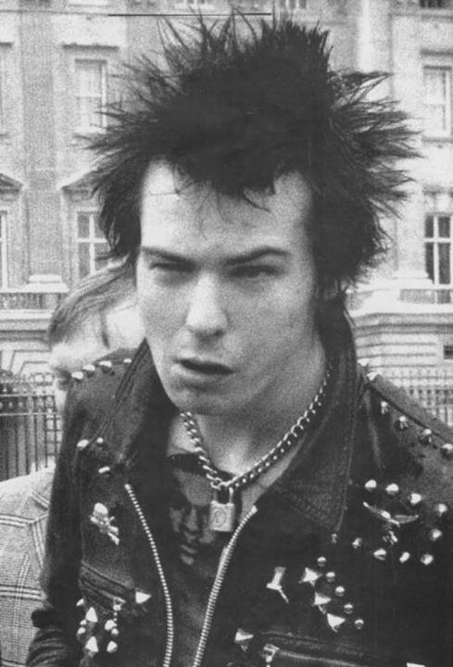  - Indirect characterization- The Rat  - « As he talks a mile a minute, his hands never stop thumping the steering wheel » He seems to be a hyper, excited guy.
Date:
Pages:
Role:
- Research
- Plot
- Character
- Style
Date:
Pages:
Role:
- Research
- Plot
- Character
- Style
Date:
Pages:
Role:
- Research
- Plot
- Character
- Style
Date:
Pages:
Role:
- Research
- Plot
- Character
- Style

