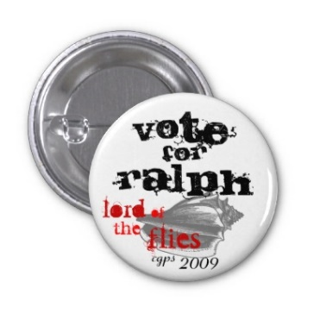
Election Campaign Project- Who should be chief? Who is the most powerful?
Who is the best person to lead the stranded boys on the island? Jack and Ralph have just had a stand -off (chapter 9) and the boys must decide who is chief. But wait, maybe Piggy would be the better option.
You will be divided into three parties- each will represent a potential leader- Ralph, Jack, or Piggy.
Your group will be responsible for:
- A leader (Pretend to be Ralph, Jack, Piggy). You will give a speech that outlines your platform, your history, your ideas. Should be about 2 minutes long and spoken on election day (Friday)
- A campaign poster with a portrait, slogans, and mission statement. (2-3 people) You must present this poster on Election Day.
- A TV ad promoting your candidate. Someone should make a script, create a back drop, film and edit. To be shown in class. (no more than one-two minutes long) (3 people +leader)
- A press release for the newspaper. Write an article in a newspaper format about why you think your candidate should win. No more than 250 words. (1 person) Follow a newspaper’s format and template. You can find templates on line. Remember this is an opinion piece.
- A facilitator on Election Day AND a social media composer.
  - Create 5 questions to ask the candidates on Election Day. Must be insightful, creative and interesting. They must focus on why this person would make the best chief.
  - Create a fake facebook or twitter account. Write a series of inspiring, persuasive tweets and facebook posts. DO NOT post for real. Just create a “press release” for your campaign. See the twitter accounts for the political parties of Canada and see how they do it. Create a document that looks similar.
- Website creater. Use www.weebly.com to create a website for your candidate. Be sure to add the slogans, the promises and some images. Use the real person for the photos!
  - A page with a biography of the “chief” and why they would make the best leader
  - A page with quotes that show why they are the best leader (5 quotes)
  - A page that outlines the chief’s platform
Criteria
- Must be in character. Follow the novel as a guideline. Don’t make attributes up.
- Must show understanding of the novel including themes, characters and symbols.
- Must show understanding of the traits of leaders- both good and bad. What makes an individual powerful?
To Begin:
- Choose leader (someone who wants to act the part)
- Delegate jobs (poster {artist}, TV ad {film person}, campaign speech {politician, speech writer}, newspaper article {journalist/writer}, quote finder {reader})
- As a group, decide on leader’s platform, why they should be chief, why we should vote for your character, what propaganda techniques will work best.
Election Day
- Begin with speeches/ posters displayed
- Read newspaper article aloud
- Show TV ads (have ads on either a flashdrive or save to youtube) Please use windows media.
- Conduct a TV interview with the facilitator.
Assessment
Each portion will be graded separately. See individual rubrics.
For ALL students- how well do you know the characters and plot in the novel? How can you combine your knowledge of the conflicts, characters, themes and symbols of the novel with an understanding of power and leadership.

