Identity: What defines me? Why does it matter?
“Never forget what you are, for surely the world will not. Make it your strength. Then it can never be your weakness. Armour yourself in it, and it will never be used to hurt you.”
― George R.R. Martin, A Game of Thrones
Notes: copy the notes that are in RED on the powerpoint. Use the subtitles below as your guide for organizing.
Why are we exploring this topic?

Identity in Adolescence: The “Experts” theory by Erik Erikson (1959)

Copy down ONE of the quotes from slide #5 that you like.

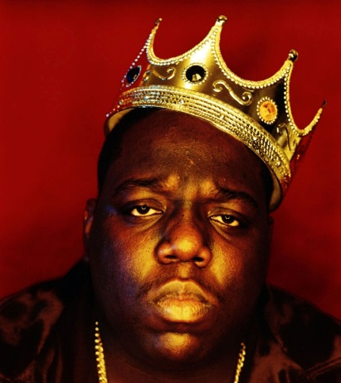
“Juicy” by Notorious BIG

It was all a dream
I used to read Word Up magazine
Salt’n’Pepa and Heavy D up in the limousine
Hangin’ pictures on my wall
Every Saturday Rap Attack, Mr. Magic, Marley Marl
Now honies play me close like butter played toast
From the Mississippi down to the east coast
Condos in Queens, indo for weeks
Sold out seats to hear Biggie Smalls speak
Livin’ life without fear
Puttin’ 5 karats in my baby girl’s ears
Lunches, brunches, interviews by the pool
Considered a fool ’cause I dropped out of high school
Stereotypes of a black male misunderstood
And it’s still all good
We used to fuss when the landlord dissed us
No heat, wonder why Christmas missed us
Birthdays was the worst days
Now we sip champagne when we thirst-ay
Uh, damn right I like the life I live
‘Cause I went from negative to positive
And it’s all good.

