
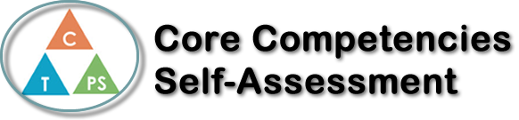
Name: Sophia Quiring | Date: Tuesday March 3, 2020

  x  How does the artifact you selected demonstrate strengths & growth in the communication competency?  In what ways might you further develop your communication competency? | Self-Reflection  I am an active listener and can respond to simple, direct questions.  Generally, when we listen to the stories that Signora Durand makes for us, we have to be actively listening the whole time, or else there will be important details that will definitely be missed. Often, she asks us to answer questions about the story so far, and we will have to answer the best we can with the structures she gave us in Italian. Communication is the most important core competency for the stories.  I can present information clearly and in an organized way.  The fumettos were a bit of a challenge for me because of the way they had to be presented. In the end, I managed to get a clear presentation of my comprehension of the Biscotti Blu story. This assignment doesn’t demonstrate any verbal communication, but the visual aspect of it was just as important.


How does the artifact you selected demonstrate strengths & growth in the thinking competencies?

In what ways might you further develop your thinking competencies?


How does the artifact you selected demonstrate strengths & growth in the personal & social competencies?

In what ways might you further develop your personal & social competencies?

Publish Your Self Assessment
You will now attach and/or embed your self-assessment to the bottom of the blog post with the artifact you have chosen. You may choose to make this post private or public. After placing your artifact on a blog post, follow the instructions below.
- Categories - Self-Assessment
- Tags - Now tag your post using the tag that corresponds to the competency that you have written about. You can choose more than one. Please use lower case letters and be exact.
  - #creativethinkingcc
  - #communicationcc
  - #criticalthinkingcc
  - #socialresponsibilitycc
  - #personalidentitycc
  - #personalawarenesscc
- Use the Add Document button located at the top of your post page and embed your self-assessment at the bottom of your blog post.
- Publish

