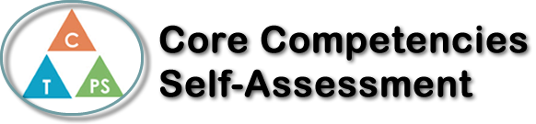

Name: Sky Pourmohseni | Date: April 6th, 2021

  x  How does the artifact you selected demonstrate strengths & growth in the communication competency?  In what ways might you further develop your communication competency? | Self-Reflection  Describe how the artifact you selected shows your strengths & growth in specific core competencies. The prompt questions on the left - or other self-assessment activities you may have done - may guide your reflection process.  I can actively respond to simple questions during class. Throughout the Fummeto stories, I actively engaged with the source material, as well as answer any questions my teacher would ask me. Practise and repetition are an essential part of learning the structures that each language has. This repetition has led structures to be ingrained in my mind, which makes learning a new language a less arduous task.  I can present information clearly but not in a organised way. Writing the 3rd story felt like blistering agony, and while the end result was disappointing, it has opened up a new window of revelation. My story contained the core elements, but lack the details needed to write a polished story. I’ve realised that I have been inconsistent with my studying patterns, leading to a spiral of depression and procrastination. I am hopeful that I can write better stories in the future. If I could change anything differently, it would be to treat Italian class more seriously.  I can recount simple experiences and activities that helped me write the 3rd story. I remembered certain translated words, and structure that helped me at least write the core elements of the story.
Publish Your Self Assessment
You will now attach and/or embed your self-assessment to the bottom of the blog post with the artifact you have chosen. You may choose to make this post private or public. After placing your artifact on a blog post, follow the instructions below.
- Categories - Self-Assessment
- Tags - Now tag your post using the tag that corresponds to the competency that you have written about. You can choose more than one. Please use lower case letters and be exact.
  - #creativethinkingcc
  - #communicationcc
  - #criticalthinkingcc
  - #socialresponsibilitycc
  - #personalidentitycc
  - #personalawarenesscc
- Use the Add Document button located at the top of your post page and embed your self-assessment at the bottom of your blog post.
- Publish

