Name: Shahrad Sharif Javaheri
Block: C
House Hunting Assignment
CLE 10
_________________________________________________________________________________________________

PART ONE: Using Craiglist-Rent.com or any other appropriate site, you are to find a housing option suitable to your needs once out of high school. Consider what city you are planning to live in.

Budget for Rent: $1350
Housing Type and Address | Rent Amount | Security Deposit | Utilities | Single, Double or Triple | Lease | Features & Restrictions
Townhouse | $2600 total (Divided by 3 = $866 per person/month) | $2600 total (Divided by 3 = $866 per person/month) | Not Include | Triple | One Year | -Furnished  -Tandem Garage  -No smoking & No pet  - 3 bedroom / 2 bath room
Link to listing and one picture:

https://vancouver.craigslist.org/rch/apa/d/richmond-3bed25bath-furnished-end-unit/6785256295.html

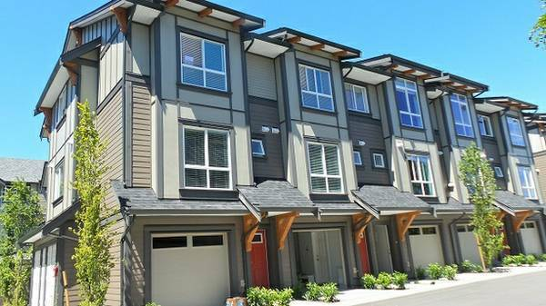

Housing Type and Address | Rent Amount | Security Deposit | Utilities | Single, Double or Triple | Lease | Features & Restrictions
Upper floor | $700  $2100 total (Divided by 3 = $700 per person/month) | $2100  $2100 total (Divided by 3 = $700 per person/month) | Shared | Triple | One Year | -Private entrance & laundry  -Unfurnished  -Parking: Street Parking  -No smoking & No pet  - 3 bedroom / 2 bath room
Link to listing and one picture:

https://vancouver.craigslist.org/van/apa/d/vancouver-3bed2bath-upper-floor/6785251510.html

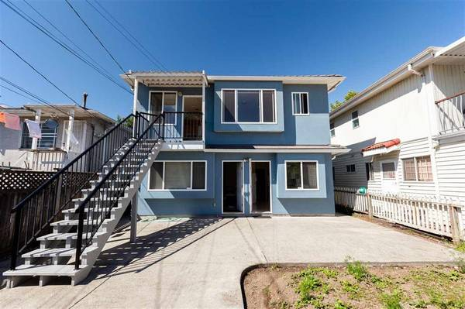

Housing Type and Address | Rent Amount | Security Deposit | Utilities | Single, Double or Triple | Lease | Features & Restrictions
Apartment | $2790 total (Divided by 2 = $1345 per person/month) | $2790 total (Divided by 2 = $1345 per person/month) | Shared | Double | One year | No Smoking and No Pets.  Also, it is possible to rent it fully furnished as it is for $2990. ( And unfurnished $2790 )  - 3 bedroom / 2 bath room
Link to listing and one picture:

https://vancouver.craigslist.org/van/apa/d/vancouver-2-bed-den-unfurnished/6791839795.html

https://images.craigslist.org/01717_f3r548MluVn_600x450.jpg

https://images.craigslist.org/00t0t_dSiDBByzCPf_600x450.jpg
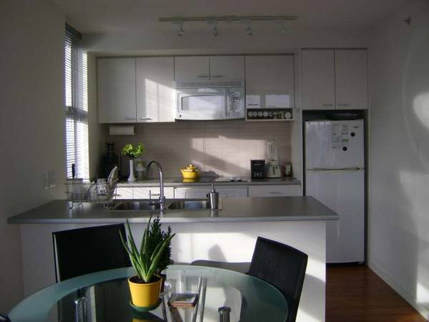

PART TWO: Housing Choice:

After reviewing your three housing options from above, which would you be more inclined to rent and why? Explain your reasoning with at least 3 specific reasons why you made that decision.

I believe the second house is the best option for me and my two other friends to rent.
First, it is the cheapest one. If I chose the third one, I might face some financial troubles later on as I have to pay twice the rent.
Second, it is much closer to Vancouver and UBC than the first option. Therefore, I can get to downtown and UBC, fast and easily with the lowest price.
Finally, it is a very beautiful house and I really like it, although it is not as good as the third one for sure.

Example information:

Housing Type & Address: Apartment #45-888 Citadel Dr. Port Coquitlam, BC
Rent: $1200 total (Divided by 2 = $600 per person/month)
Security Deposit: $1200 (Divided by 2 = $600/person)
Budget for rent: $1300
Leftover money rent: $100
Single/Double: Double
Lease: 6 months
Utilities: Not included
Location:
Housing Features: - Two Bedrooms
- Two Bathrooms
- In-suite laundry and dryer
- No pets
- Granite countertops
- free parking spot underground
Link: and picture of the listing

