Newspaper Assignment

Week 1

ALERT: Two arrested in Red Deer drugs seizure
February 10, 2022 ALERT, Drugs, Firearms, RCMP Alberta, _ Alberta
Red Deer, Alberta – Two people were arrested after an ALERT investigation in Red Deer turned up a variety of drugs and a loaded shotgun.
On January 26, 2022 a home in the Red Deer neighbourhood of Vanier Woods was searched. The search warrant execution capped of a three-month investigation by ALERT, with the assistance of Red Deer RCMP.

“This was a quick-hit investigation with an immediate, positive community impact for Red Deer. ALERT will continue to work alongside its partner agencies in getting harmful drugs off the street.” Staff Sgt. Shawn Wallace, ALERT Calgary
As result of the search, ALERT had seized:
Loaded shotgun;
414 grams of methamphetamine;
174 suspected fentanyl pills;
28 grams of cocaine;
$4,450 cash.
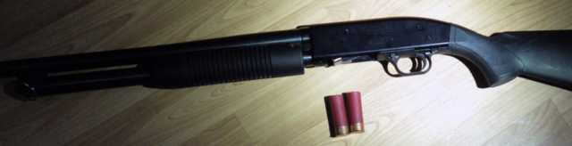(ALERT) Loaded shotgun
The drugs seized have an estimated street value of $25,000. The pills are being submitted for further analysis.
Randi St. German, 41, of Red Deer was charged with possession of drugs for the purpose of trafficking, possession of proceeds of crime, breach of a firearms prohibition order, unauthorized possession of a firearm, and possession of a loaded firearm.
Erick Becker, 33, of Red Deer was charged with drug trafficking, possession of proceeds of crime, and breach of a release order.
Becker was charged for similar offences in relation to an ALERT investigation from February 2021.
Members of the public who suspect drug or gang activity in their community can call local police, or contact Crime Stoppers at 1-800-222-TIPS (8477). Crime Stoppers is always anonymous.
ALERT was established and is funded by the Alberta Government and is a compilation of the province’s most sophisticated law enforcement resources committed to tackling serious and organized crime.
Section 5 – Controlled Drugs and Substances Act – Trafficking in Substance
5 (1) No person shall traffic in a substance included in Schedule I, II, III, IV or V or in any substance represented or held out by that person to be such a substance.
Trafficking in Substance is when an individual is transporting or illegally importing drugs with the intention of selling and distributing those illegal drugs to others to make a profit. The drugs the individual has must be of such a large amount that it is considered not for personal use only that amount is specific to each individual drug.
Two people are arrested in an investigation in Red Deer, Alberta and police confiscated large amounts of numerous illegal drugs. The illegal drugs including 414 grams of methamphetamine, 174 pills suspected to have been fentanyl, and 28 grams of cocaine. These drugs have the approximate street value of $25,000. Methamphetamine, fentanyl, and cocaine are all included in Schedule I of the Controlled Drugs and Substances Act and of such large amounts to be considered more than personal use. Therefore, the illicit drugs are being transported to others for money. Randi St. German can be charged with trafficking in substance. Erik Becker can be charged with trafficking in substance.

Week 2

Firearms seized following drug arrests at a home in Grande Cache, Alberta
February 17, 2022 ALERT, Drugs, Firearms, Grande Prairie, RCMP Alberta, Spotlight, _ Alberta
Grande Prairie, Alberta – Nine firearms, none of which were lawfully possessed, were seized from a pair of west-central Alberta drug dealers. The firearms and drugs were seized after a home in Grande Cache, Alta. was searched.
ALERT Grande Prairie’s organized crime and gang team made the seizure on February 9, 2022. ALERT seized nine firearms and an estimated $25,000 worth of fentanyl and methamphetamine.
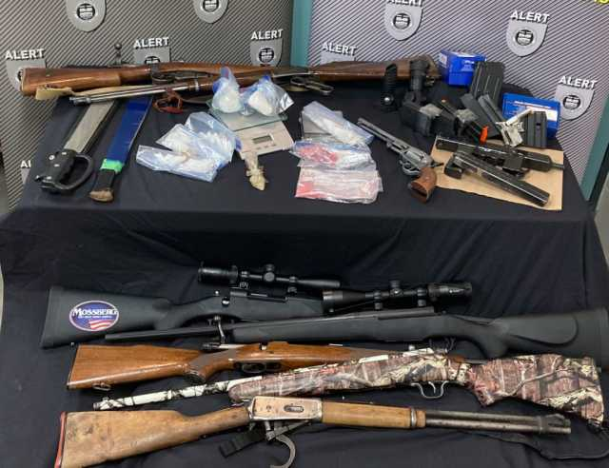ALERT seized nine firearms and an estimated $25,000 worth of fentanyl and methamphetamine.
ALERT received assistance on the investigation from RCMP detachments in Grande Cache, Hinton, and Grande Prairie.

“I am grateful for the work and dedication the members of ALERT, and other assisting units, put into this investigation these last months. This has made a significant and positive impact to our community by removing illicit drugs from our streets.” Sergeant Gord Hughes, Grande Cache RCMP
Two people from Grande Cache were arrested and charged. ALERT began investigating their suspected drug trafficking activities in November 2021.
Elijah Hallock, 31, was charged with drug trafficking, possession of drugs for the purpose of trafficking, and possession of proceeds of crime.
Darwin Hallock, 26, was charged with drug trafficking and unsafe storage of a firearm.
Members of the public who suspect drug or gang activity in their community can call local police, or contact Crime Stoppers at 1-800-222-TIPS (8477). Crime Stoppers is always anonymous.
ALERT was established and is funded by the Alberta Government and is a compilation of the province’s most sophisticated law enforcement resources committed to tackling serious and organized crime.
Section 5 – Controlled Drugs and Substances Act – Trafficking in Substance
5 (1) No person shall traffic in a substance included in Schedule I, II, III, IV or V or in any substance represented or held out by that person to be such a substance.
Trafficking in Substance is when an individual is transporting or illegally importing drugs with the intention of selling and distributing those illegal drugs to others to make a profit. The drugs the individual has must be of such a large amount that it is considered not for personal use only that amount is specific to each individual drug.
Elijah and Darwin Hallock had methamphetamine and fentanyl around $25,000 worth seized by the police. Both methamphetamine and fentanyl are included under Schedule I of the Controlled Drugs and Substances Act. The drugs were illegal and there was $25,000 worth there. The amount of drugs are much more than one or two individuals could use. These illegal drugs are then being taken to others with the intention of selling the drugs. Elijah Hallock can be charged with trafficking in substance. Darwin Hallock can each be charged with trafficking in substance.

Week 3

Marystown man arrested in a car with a brick of cocaine at his feet loses bid for third trial
Newfoundland and Labrador appellate court dismisses Dennis Brake's latest appeal
Tara Bradbury · Reporter | Posted: Feb. 24, 2022, 9:06 p.m. | Updated: Feb. 24, 2022, 9:06 p.m. | 3 Min Read
123RF Stock Photo

ST. JOHN'S, N.L. — Having been convicted of possessing cocaine for trafficking, then winning a new trial before being convicted a second time, a Marystown man has lost his latest appeal.
Dennis Brake had asked the province’s Court of Appeal to grant him a third trial, arguing the second trial judge had made legal errors, including misapplying the law of circumstantial evidence, finding Brake had been in possession of the cocaine and requiring him to prove that he hadn’t been.
Brake was charged in June 2016 after a police investigation into another man’s suspected drug dealing. Officers had watched the man put a brick of cocaine in the trunk of his car in Paradise before heading onto the highway and stopping at the Irving Big Stop in Goobies. They watched as the vehicle parked at the side of the gas station and Brake got in. The driver got out and went to the trunk before getting back in empty-handed, then moved the vehicle behind a nearby tractor-trailer.
Officers saw the driver's legs as he got out of the car again and went back to the trunk, then returned to the driver's seat and drove the car back to its original position in the parking lot. That's when they descended on the vehicle, finding the brick of cocaine — later determined to be valued between $45,000 and $70,000 — in a plastic bag at Brake's feet.
Brake went to trial in 2017, testifying he had not seen any bag in the car and would have assumed it was a trash bag. When the driver had exited the car behind the trailer, Brake said, he believed the man had gone to pee.
Brake was convicted and sentenced to two years in prison, but won a new trial when the Court of Appeal found the trial judge had erred in finding Brake had known about the cocaine and had possession of it.
Brake went to trial again in 2019 in provincial court in St. John’s and argued for an acquittal on a similar basis, saying there had been no evidence to suggest he had known about the cocaine. The judge rejected his argument and found him guilty, sentencing him in February 2020 to two years plus a day in prison. Brake filed an appeal the same day.
Justice Lois Hoegg, Justice William Goodridge and Justice Gillian Butler found the second trial judge’s had not erred by rejecting other possible inferences for the cocaine to be at Brake’s feet. Brake had not testified and there was no evidence suggesting another way or reason for the cocaine to get there, they noted. The trial judge’s conclusion that Brake had been in possession of the cocaine was not made in error, they found.
“It was open to the judge to infer from the cumulative effect of all the evidence and circumstances that (the other man) would not be retrieving a very valuable brick of cocaine from the trunk of his car and it being found at Mr. Brake’s feet moments later without Mr. Brake’s knowledge that the cocaine was at his feet, that he had a measure of control over it being put there, and that he consented to it being there,” Hoegg wrote in the decision, concurred by her colleagues.
The trial judge used rhetorical questions to illustrate why he didn’t have reasonable doubt about Brake’s guilt and this didn’t put the onus on Brake to prove himself innocent, Hoegg wrote.
The appellate judges dismissed the appeal Feb. 15. Brake had been granted bail pending their decision, with the condition that he turn himself in to police within 24 hours if the appeal was eventually dismissed.

Section 5 – Controlled Drugs and Substances Act – Trafficking in Substance
5 (1) No person shall traffic in a substance included in Schedule I, II, III, IV or V or in any substance represented or held out by that person to be such a substance.
Trafficking in Substance is when an individual is transporting or illegally importing drugs with the intention of selling and distributing those illegal drugs to others to make a profit. The drugs the individual has must be of such a large amount that it is considered not for personal use only that amount is specific to each individual drug.

Dennis Brake was found with a brick of cocaine in a bag at his feet during a police investigation in June 2016. He was convicted and on appeal he won a new trial. He was convicted at the second trial, appealed for a third trial, and has lost this appeal just recently. The cocaine was worth around $45,000 to $70,000 and with the drug being worth so much the cocaine is clearly a vast amount. This means the cocaine is more than what is considered of personal use only. Thus, the cocaine was being distributed to Dennis Brake for him to then sell the cocaine to others to make a profit. Cocaine is an illegal substance and part of Schedule I of the Controlled Drugs and Substances Act. Dennis Brake can be charged individually with trafficking in substance.

Week 4

Operator of Ontario heavy equipment business arrested in $200 million cocaine bust

The cocaine was travelling a winding route from Costa Rica, through Colombia, Jamaica and the Dominican Republic inside secret compartments in a large piece of machinery, authorities said.
By Peter Edwards Staff Reporter
Fri., March 4, 2022timer3 min. read
JOIN THE CONVERSATION (10 )
A Brantford man who runs a heavy equipment repair business has been charged in a massive cocaine importing bust that has allegedly taken almost $200 million of the drug off the streets of the GTA.
The arrest was announced by the Canada Border Services Agency and the Royal Canadian Mounted Police this week, almost a month after 1.5 tonnes of cocaine was seized by CBSA officers in Saint John, N.B.
The shipment was destined for a heavy equipment business in Brantford, authorities said.
The intercepted cocaine was removed in New Brunswick on Jan. 7 and the rest of the shipment continued on to Brantford, where arrests were made on Jan. 27.
Authorities didn’t say which crime groups were involved in the smuggling operation.
The cocaine was travelling a winding route from Costa Rica, through Colombia, Jamaica and the Dominican Republic inside secret compartments in a large piece of machinery, authorities said.
The CBSA estimated the value of the seizure at approximately $198,000,000.
“The narcotics were discovered concealed inside the cargo of a marine container; this represents the largest quantity of cocaine seized from a marine shipping container in Atlantic Canada in three decades,” the RCMP said in a prepared statement.
Authorities said this week that the Brantford operation began in the fall of 2021, when the CBSA was tipped off about cocaine being shipped out of Central America.
“In December 2021, CBSA began tracking a marine shipping container of interest which contained goods imported by a Greater Toronto Area (GTA) resident and exported from Central America, with a final destination of Saint John, NB.,” the RCMP said in a prepared statement.
Five of the six people arrested in Brantford on Jan. 27 have since been freed with no charges.
Kyle Alexander Purvis, 34, of Brantford was charged with importing a controlled substance into Canada and possession of a controlled substance for the purpose of trafficking.
Corporate records list Purvis as director of a heavy equipment repair and service company on Mohawk Street in Brantford.
The Brantford bust drew praise from Marco Mendicino, federal minister of public safety, who praised the CBSA and law enforcement agencies for their efforts to “disrupt criminal activity, protect Canadians and their families from the harmful impacts of drug smuggling, and ensure the integrity of our border.”
CBSA President John Ossowski called the case “a great example of how our officers in Canada and around the world work closely with our law enforcement partners to share intelligence, prevent illicit drugs from entering Canada, and protect our communities.”
RCMP deputy commissioner Michael Duheme called the case a “great example of RCMP Federal policing’s effective joint work with its partners.”
The bust follows a pair of recent drug trafficking cases involving large quantities of cocaine arriving in Ontario via Central and South America.
In November 2021, two southern Ontario drug traffickers were hit with life sentences after being convicted in a massive cocaine bust linked to Mexico’s Sinaloa cartel.
That operation involved hiding cocaine inside large stone boulders that were imported from Mexico and later from Brazil. According to the Crown, it was the largest importation of cocaine ever prosecuted in Ontario.
Cocaine prices vary with the purity of the drug. The cocaine in the Kompon/ Buffone case was 93 per cent pure when it arrived in Canada, was then distributed to other criminal organizations.
At the time, Niagara police said the case was the first time he has heard of Mexican cartel members operating inside Ontario. At the time of those arrests, the Sinaloa cartel was headed by Joaquin (El Chapo) Guzman, now imprisoned in the U.S.
In August 2017, the OPP announced police had intercepted 1,062 kilograms of 97-per-cent-pure cocaine with a street value of $250 million.
That case involved cocaine shipped by a Mexican cartel to Canada through Argentina.
In Argentina, the case was called Bobinas Blancas — “Project White Coils” — because some of the cocaine was shipped in containers of steel coils.
Police in Argentina found about 1,500 kilograms cocaine inside eight steel coils, ready to be shipped to Canada and Spain.
Weighing nearly 10,000 kilograms each, the coils were engineered to create a magnetic shield that blocked police scanners, police said.

Section 5 – Controlled Drugs and Substances Act – Trafficking in Substance
5 (1) No person shall traffic in a substance included in Schedule I, II, III, IV or V or in any substance represented or held out by that person to be such a substance.
Trafficking in Substance is when an individual is transporting or illegally importing drugs with the intention of selling and distributing those illegal drugs to others to make a profit. The drugs the individual has must be of such a large amount that it is considered not for personal use only that amount is specific to each individual drug.
Kyle Alexander Purvis in Brantford, Ontario was arrested on January 27, 2022. The police found the cocaine at a heavy equipment repair business which Kyle Alexander Purvis runs. The copious quantity of cocaine was hidden in the machinery. Cocaine is illegal and found under Schedule I of the Controlled Drugs and Substances Act. The cocaine found was worth around $198,000,000 which is an abundant amount more than that of use for one individual. The cocaine was hidden in the machinery so the cocaine could be transported to Canada then transported to make money selling it to others. Kyle Alexander Purvis can be charged with trafficking in substance.

Week 5

RCMP seize six kilograms of crystal methamphetamine; two people arrested
March 7, 2022
Woodstock, New Brunswick
News release

Images

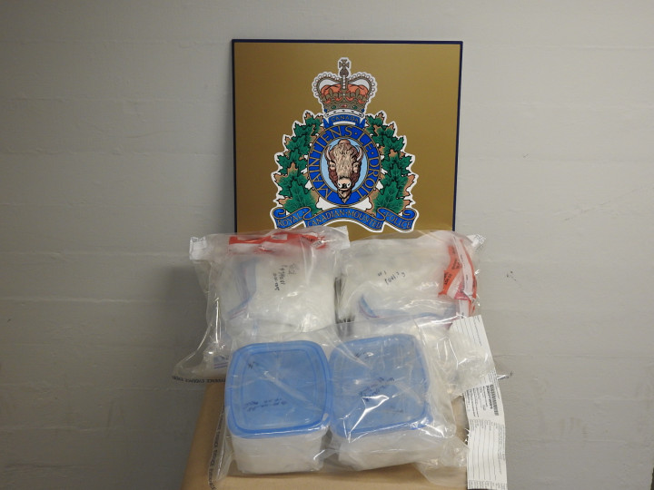

The New Brunswick RCMP has arrested two people and seized six kilograms of what is believed to be crystal methamphetamine as part of an ongoing drug investigation in Lower Woodstock, N.B.
On February 25, 2022, the New Brunswick RCMP's Federal Serious and Organized Crime unit executed a search warrant at a home on Pine Street in Lower Woodstock as part of an ongoing drug-trafficking investigation. During the search, police seized approximately four kilograms of what is believed to be crystal methamphetamine, and drug trafficking paraphernalia. A 21-year-old woman from Lower Woodstock was arrested at the scene and later released pending a future court appearance. On March 2, police arrested a 19-year-old woman in connection with the investigation and seized an additional two kilograms of what is believed to be crystal methamphetamine. The woman was later released pending a future court appearance.
This investigation was the result of an operation by the Federal Serious and Organized Crime unit, which has the broad mandate of addressing all types of federal investigations, such as secure Canada's borders, investigate criminality related to national security, serious and organized crime, financial crime, high-level drug enforcement, ensure the safety of critical infrastructure, as well as enforcing federal laws within New Brunswick.
The public plays an important role in helping to reduce, prevent and solve crime, including the trafficking of illegal drugs. Anyone with information about, or who suspects, illegal drug activity in their neighbourhood is asked to contact their local police. Information can also be provided anonymously through Crime Stoppers at 1-800-222-TIPS (8477), by downloading the secure P3 Mobile App, or by Secure Web Tips at www.crimenb.ca.
The investigation is ongoing.
Section 5 – Controlled Drugs and Substances Act – Trafficking in Substance
5 (1) No person shall traffic in a substance included in Schedule I, II, III, IV or V or in any substance represented or held out by that person to be such a substance.
Trafficking in Substance is when an individual is transporting or illegally importing drugs with the intention of selling and distributing those illegal drugs to others to make a profit. The drugs the individual has must be of such a large amount that it is considered not for personal use only that amount is specific to each individual drug.
A 21-year-old woman’s home was searched, and the police found 4 kilograms of crystal methamphetamine. The 21-year-old woman was arrested on Feb. 25th, 2022, in Lower Woodstock, New Brunswick. Crystal methamphetamine is illicit and part of Schedule I of the Controlled Drugs and Substances Act. The 4 kilograms of crystal methamphetamine is considered of such a large total that it is more than personal use exclusively. For this reason, it can be assumed that the crystal methamphetamine was being sold to others. The 21-year-old woman can be charged with trafficking in substance.
Works cited
Bradbury, T. (2022, February 24). Marystown man arrested in a car with a brick of cocaine at his feet loses bid for third trial. Saltwire Atlantic Canada. Retrieved February 27, 2022, from https://www.saltwire.com/atlantic-canada/news/marystown-man-arrested-in-a-car-with-a-brick-of-cocaine-at-his-feet-loses-bid-for-third-trial-100697924/
Canada Police Report. (2022, February 10). ALERT: Two arrested in Red Deer drugs seizure. Canada Police Report. Retrieved February 12, 2022, from https://www.canadapolicereport.ca/2022/02/10/alert-two-arrested-in-red-deer-drugs-seizure-2022/
Canada Police Report. (2022, February 17). Firearms seized following drug arrests at a home in Grande Cache, Alberta. Canada Police Report. Retrieved February 19, 2022, from https://www.canadapolicereport.ca/2022/02/17/firearms-seized-following-drug-arrests-at-a-home-in-grande-cache-alberta/
Edwards, P. (2022, March 4). Operator of Ontario heavy equipment business arrested in $200 million cocaine bust. Toronto Star. Retrieved March 5, 2022, from https://www.thestar.com/news/gta/2022/03/04/operator-of-ontario-heavy-equipment-business-arrested-in-200-million-cocaine-bust.html
Government of Canada. (2022, February 2). Controlled Drugs and Substances Act (S.C. 1996, c. 19): Trafficking in Substance. Justice Laws Website. Retrieved February 6, 2022, from https://laws-lois.justice.gc.ca/eng/acts/c-38.8/section-5.html
Royal Canadian Mounted Police. (2022, March 7). RCMP seize six kilograms of crystal methamphetamine; two people arrested. Royal Canadian Mounted Police. Retrieved March 12, 2022, from https://www.rcmp-grc.gc.ca/en/news/2022/rcmp-seize-six-kilograms-crystal-methamphetamine-two-people-arrested

Canada Police Report. (2022, February 10). ALERT: Two arrested in Red Deer drugs seizure. Canada Police Report. Retrieved February 12, 2022, from https://www.canadapolicereport.ca/2022/02/10/alert-two-arrested-in-red-deer-drugs-seizure-2022/
Government of Canada. (2022, February 2). Controlled Drugs and Substances Act (S.C. 1996, c. 19): Trafficking in Substance. Justice Laws Website. Retrieved February 6, 2022, from https://laws-lois.justice.gc.ca/eng/acts/c-38.8/section-5.html
Canada Police Report. (2022, February 10). ALERT: Two arrested in Red Deer drugs seizure. Canada Police Report. Retrieved February 12, 2022, from https://www.canadapolicereport.ca/2022/02/10/alert-two-arrested-in-red-deer-drugs-seizure-2022/
Canada Police Report. (2022, February 17). Firearms seized following drug arrests at a home in Grande Cache, Alberta. Canada Police Report. Retrieved February 19, 2022, from https://www.canadapolicereport.ca/2022/02/17/firearms-seized-following-drug-arrests-at-a-home-in-grande-cache-alberta/
Government of Canada. (2022, February 2). Controlled Drugs and Substances Act (S.C. 1996, c. 19): Trafficking in Substance. Justice Laws Website. Retrieved February 6, 2022, from https://laws-lois.justice.gc.ca/eng/acts/c-38.8/section-5.html
Canada Police Report. (2022, February 17). Firearms seized following drug arrests at a home in Grande Cache, Alberta. Canada Police Report. Retrieved February 19, 2022, from https://www.canadapolicereport.ca/2022/02/17/firearms-seized-following-drug-arrests-at-a-home-in-grande-cache-alberta/
Bradbury, T. (2022, February 24). Marystown man arrested in a car with a brick of cocaine at his feet loses bid for third trial. Saltwire Atlantic Canada. Retrieved February 27, 2022, from https://www.saltwire.com/atlantic-canada/news/marystown-man-arrested-in-a-car-with-a-brick-of-cocaine-at-his-feet-loses-bid-for-third-trial-100697924/
Government of Canada. (2022, February 2). Controlled Drugs and Substances Act (S.C. 1996, c. 19): Trafficking in Substance. Justice Laws Website. Retrieved February 6, 2022, from https://laws-lois.justice.gc.ca/eng/acts/c-38.8/section-5.html
Bradbury, T. (2022, February 24). Marystown man arrested in a car with a brick of cocaine at his feet loses bid for third trial. Saltwire Atlantic Canada. Retrieved February 27, 2022, from https://www.saltwire.com/atlantic-canada/news/marystown-man-arrested-in-a-car-with-a-brick-of-cocaine-at-his-feet-loses-bid-for-third-trial-100697924/
Edwards, P. (2022, March 4). Operator of Ontario heavy equipment business arrested in $200 million cocaine bust. Toronto Star. Retrieved March 5, 2022, from https://www.thestar.com/news/gta/2022/03/04/operator-of-ontario-heavy-equipment-business-arrested-in-200-million-cocaine-bust.html
Government of Canada. (2022, February 2). Controlled Drugs and Substances Act (S.C. 1996, c. 19): Trafficking in Substance. Justice Laws Website. Retrieved February 6, 2022, from https://laws-lois.justice.gc.ca/eng/acts/c-38.8/section-5.html
Edwards, P. (2022, March 4). Operator of Ontario heavy equipment business arrested in $200 million cocaine bust. Toronto Star. Retrieved March 5, 2022, from https://www.thestar.com/news/gta/2022/03/04/operator-of-ontario-heavy-equipment-business-arrested-in-200-million-cocaine-bust.html
Royal Canadian Mounted Police. (2022, March 7). RCMP seize six kilograms of crystal methamphetamine; two people arrested. Royal Canadian Mounted Police. Retrieved March 12, 2022, from https://www.rcmp-grc.gc.ca/en/news/2022/rcmp-seize-six-kilograms-crystal-methamphetamine-two-people-arrested
Government of Canada. (2022, February 2). Controlled Drugs and Substances Act (S.C. 1996, c. 19): Trafficking in Substance. Justice Laws Website. Retrieved February 6, 2022, from https://laws-lois.justice.gc.ca/eng/acts/c-38.8/section-5.html
Royal Canadian Mounted Police. (2022, March 7). RCMP seize six kilograms of crystal methamphetamine; two people arrested. Royal Canadian Mounted Police. Retrieved March 12, 2022, from https://www.rcmp-grc.gc.ca/en/news/2022/rcmp-seize-six-kilograms-crystal-methamphetamine-two-people-arrested

