Legend:
- Diction
- Symbolism
- Conflict
- Irony
- Author Background
- Other Poetic Devices
- Thematic Statements
- Imagery
- Setting
Setting:
- Physical
  - The physical setting jumps through time, showing his present day in the park, then his youth, back to the war ground, to the time he enlisted and back to his torturous present day life
- Emotional
  - Just as the physical setting does, the emotional setting plays with the reader’s emotions. When he is talking about his present life, the reader feels saddened, pitiful and hopeless. When we are transported back to his youth the reader has feeling of amusement and happiness, but these moments are always interrupted by a sad awakening to his present life (just as the speaker experiences daily)

Disabled
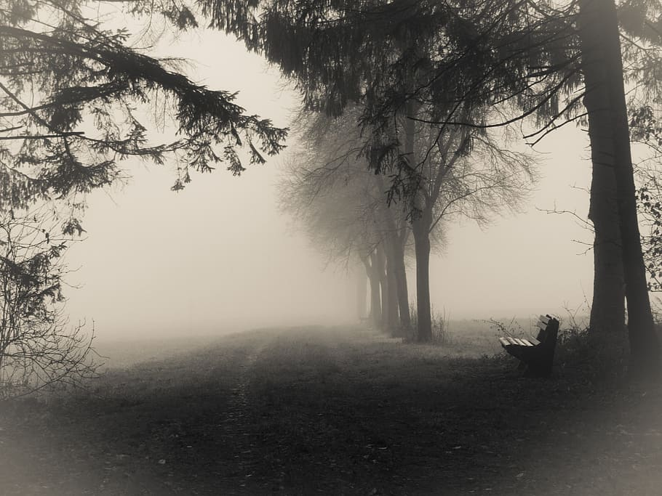
BY WILFRED OWEN
He sat in a wheeled chair, waiting for dark,
And shivered in his ghastly suit of grey,
Legless, sewn short at elbow. Through the park
Voices of boys rang saddening like a hymn,
Voices of play and pleasure after day,
Till gathering sleep had mothered them from him.
* * * * *
About this time Town used to swing so gay
When glow-lamps budded in the light-blue trees,
And girls glanced lovelier as the air grew dim,—
In the old times, before he threw away his knees.
Now he will never feel again how slim
Girls' waists are, or how warm their subtle hands,
All of them touch him like some queer disease.
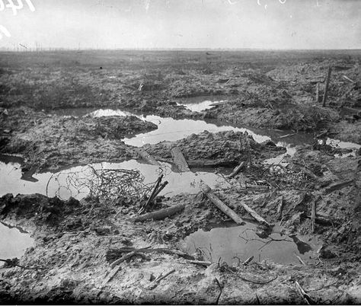
* * * * *
There was an artist silly for his face,
For it was younger than his youth, last year.
Now, he is old; his back will never brace;
He's lost his colour very far from here,
Poured it down shell-holes till the veins ran dry,
And half his lifetime lapsed in the hot race
And leap of purple spurted from his thigh.
* * * * *
One time he liked a blood-smear down his leg,
After the matches carried shoulder-high.
It was after football, when he'd drunk a peg,
He thought he'd better join. He wonders why.
Someone had said he'd look a god in kilts.
That's why; and maybe, too, to please his Meg,
Aye, that was it, to please the giddy jilts,
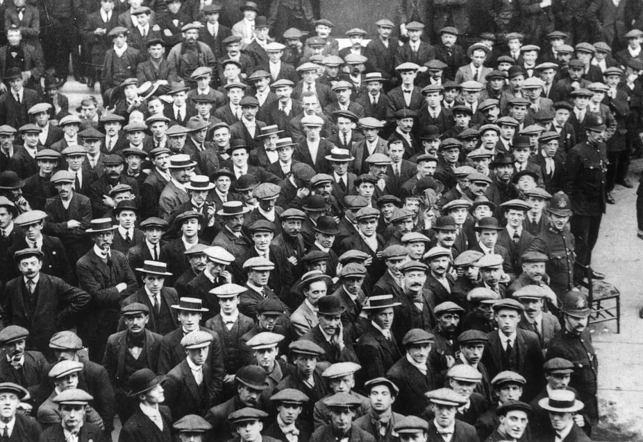
He asked to join. He didn't have to beg;
Smiling they wrote his lie: aged nineteen years.
Germans he scarcely thought of, all their guilt,
And Austria's, did not move him. And no fears
Of Fear came yet. He thought of jewelled hilts
For daggers in plaid socks; of smart salutes;
And care of arms; and leave; and pay arrears;
Esprit de corps; and hints for young recruits.
And soon, he was drafted out with drums and cheers.
* * * * *
Some cheered him home, but not as crowds cheer Goal.
Only a solemn man who brought him fruits

Thanked him; and then inquired about his soul.
* * * * *
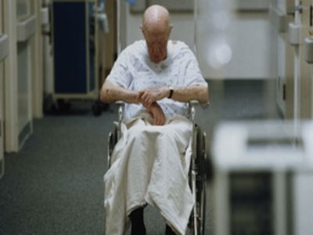
Now, he will spend a few sick years in institutes,
And do what things the rules consider wise,
And take whatever pity they may dole.
Tonight he noticed how the women's eyes
Passed from him to the strong men that were whole.
How cold and late it is! Why don't they come
And put him into bed? Why don't they come?
Thematic statements:
- One’s life might seem amusing and unimportant, but it can easily be taken away.
- One must appreciate what they have in the present so that nothing will be regretted in the future.
- One’s trauma may not be overseen as the memories flow back and reveal the true reality
- One will learn certain experiences from their youth not knowing the consequences it may have in their future
Holocaust (Final Solution)

The genocide of the Jews was a culmination of a decade of increasingly severe discriminatory measures. This can connect to the poem because of the feeling of isolation. Anti-Jewish policies escalated during WWII which made the Jewish population feel excluded which is the same feeling the speaker had in the poem. For example, the Jewish people were put into the ghettos where they lived in overcrowded and unsanitary conditions. These conditions led to loneliness, depression and exclusion from society which is similar to the speaker’s emotions.

The Nazis used euphemistic language to hide the realities of their crimes. They used the term “Final Solution” to refer to their plan exterminate the Jewish population. The author of Disabled also used euphemistic language to try to ease the reader however it is interrupted by the harsh realities of the speaker’s present day life.

The “Final Solution” was a repressive solution to many long and outstanding conflicts.
It symbolizes the effects of worldwide conflict and the importance of understanding humanity’s past mistakes so we can make our future a better place. It was a repressive solution to many long and outstanding conflicts.

Work Cited

United States Holocaust Memorial Museum, United States Holocaust Memorial Museum, 8 Dec. 2006, encyclopedia.ushmm.org/content/en/article/final-solution-overview.

“Disabled, Wilfred Owen Poem Analysis.” GCSE English Analysis, 17 Dec. 2018, gcseenglishanalysis.com/disabled-wilfred-owen/.

External conflict (women are repulsed by him, person vs. person)
Internal conflict (person vs. themselves, beating themselves up over what happened) due to external/societal pressures (the rest of the world putting the blame on the Germans)

