# Thermos challenge

## Prototype #1 :

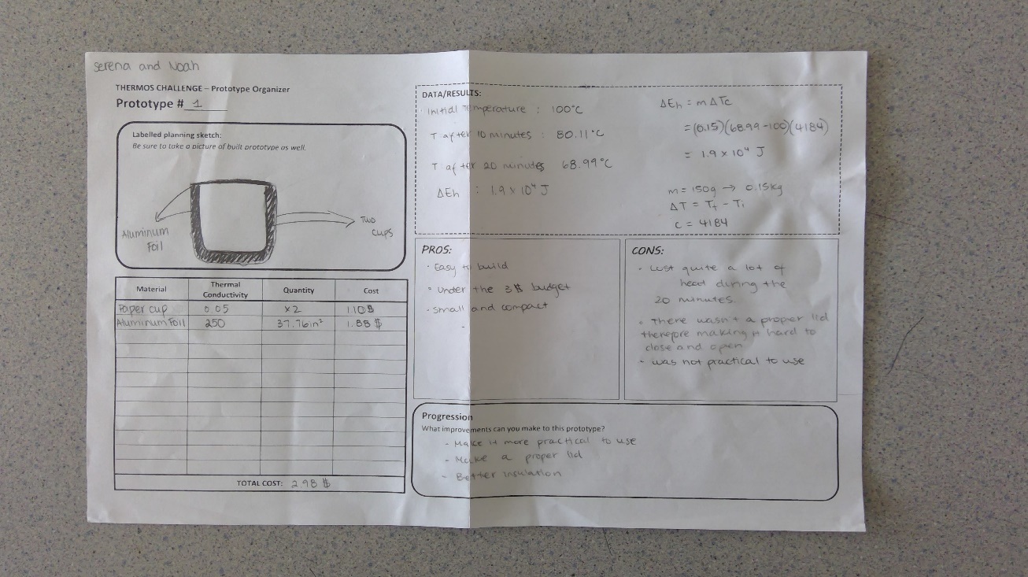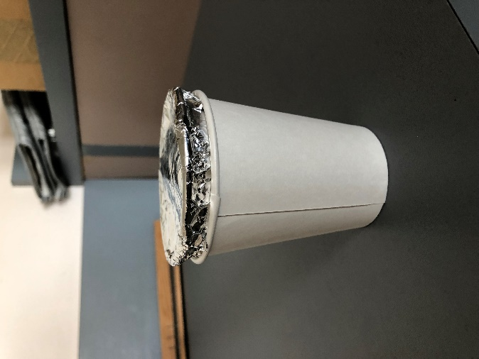

Our first prototype consisted of two paper cups and aluminum foil that was stacked together to create a ‘double wall’ insulation. This prototype was very simple, but it out performed our second prototype that was more intricate. We think the low conductivity level of the paper cup it helped convect heat throughout the hot water. It also didn’t conduct a lot of heat, so less heat radiated outwards. The tin foil wasn’t a very effective lid, but it was a good heat reflector since hot air rises, it reflected the hot air back towards the water. To make this prototype better, we should have placed an insulator (low thermal conductivity) on top of the aluminum foil lid so that the heat would not escape as easily as it did. This prototype helped us understand the basics of how heat reacts in an enclosed space and gave us a starting point to our other remaining prototypes.

## Prototype #2 :

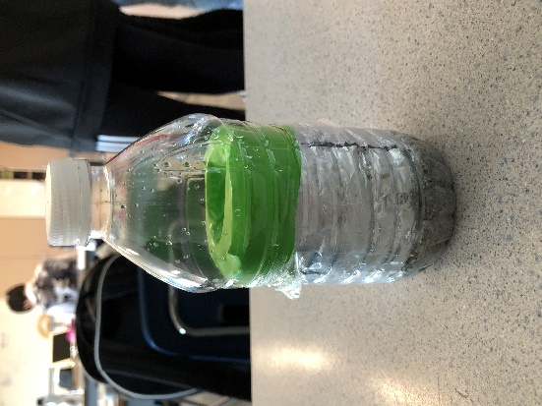

Our second prototype was a failure. We did not take in consideration the heat of the water and the plastic material used. As soon as we poured the hot water into the vessel, it began to melt. We started by cutting two plastic water bottles to a substantial size to fit 150ml of water. We took the bottom piece of a bottle, wrapped it tin foil, and wedged it into another plastic bottle to create the ‘double wall’ insulation. We added a layer of sand on the bottom to test the effectiveness of sand as a cheap insulator. We had difficulty finding a tight-fitted lid to place around it. We decided to place a balloon over the top to simulate a gripped and ‘air tight’ seal, it was not effective. This prototype lost heat the quickest out of all our prototypes since it was poorly insulated on top and the sand did not provide enough insulation because of the small air pockets in sand. To improve this prototype, we should have put the aluminum foil on the inside rather than on the outside of the small bottle so that the heat would reflect and create more convection throughout the water.

## Prototype #3 :

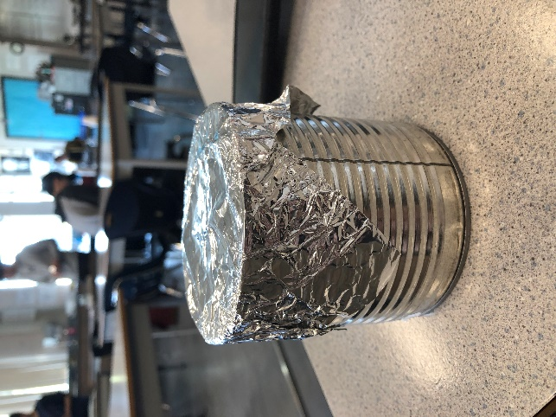Our last prototype was made of two metal cans, tin foil, tape and foam underlay. We placed a smaller metal can inside the larger can to again create a double wall insulation. We lined the larger can with foam underlayer and covered it with tin foil as a ‘lid’. Our priority was to improve the lid since most of the rising heat was escaping through to unsecure piece of aluminum foil. Although heat was reflected from the foil, it was releasing most of the heat since it was not securely positioned on top. This prototype performed the best out of 3 prototypes so, we decided to further improve this prototype to create the final product.

# **temperature vs time graph of 3 prototypes**

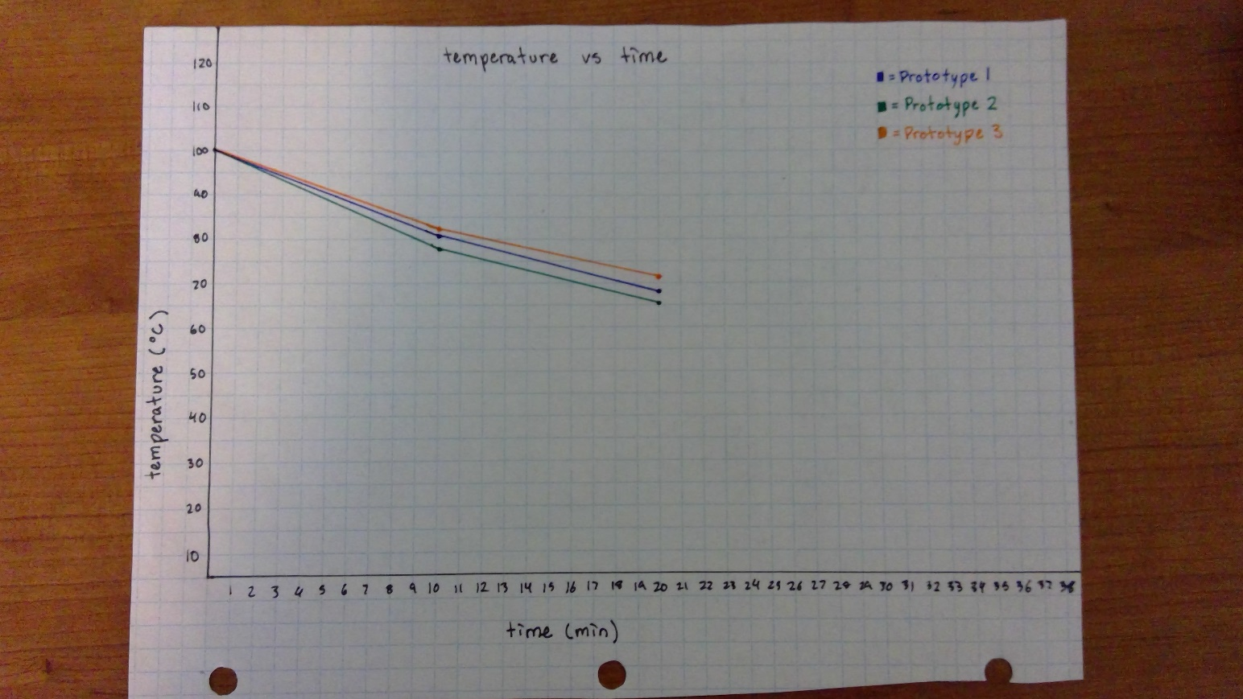

# Final protoype :

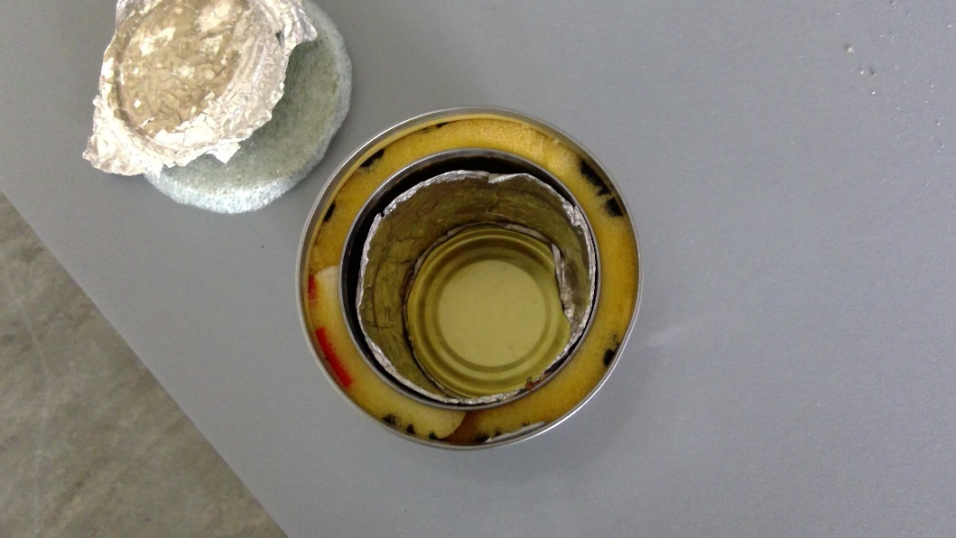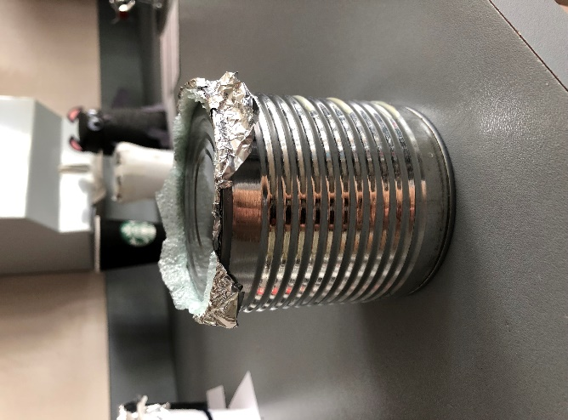

Materials:

* Large metal can with lid
* Small metal can
* Foam Insulation
* Aluminum foil
* Foam underlay

Results:

Cost: $3.40

Ti = 84.50 °C

Tf = 54.26 °C

Difference = 30.24 °C

For our final product, we decided to use two metal cans, aluminum foil and two different types of foam insulator. It was the improved version of our third prototype.  We decided to use these materials because we thought they would be the most effective but after learning more about thermal conductivity, we were proven wrong. As we learned, metal has a high thermal conductivity therefore transferring heat easily. We used metal cans so in the end, they would lose heat faster than materials with low thermal conductivity. The pros of our final product was the foam insulators we used around and on top of the thermos and the aluminum foil we put on the inside of the small can. Both foam insulators we used had very low thermal conductivity therefore being a better material to prohibit heat transfer. For the aluminum foil we put on the inside of the can, its high thermal conductivity level allowed more heat particles to be transferred through the water creating more kinetic energy and therefore, potential energy by allowing heat particles to convect and maintain a high-water temperature. Since the metal cans absorbed most of the heat, the potential and kinetic energy decreased at a faster rate because heat energy was transferred to the can instead of the water.

Throughout all our many different prototypes we tested, we learned the importance of a secure lid. Convection is the transfer of heat by movement of a fluid, warm air rises, and cold air replaces it. Since warm air rises in the thermos, the lid we make must prevent heat being lost while the warm air rises and cold air replaces it. We created the lid by using a metal lid, foam insulator and aluminum foil. In the end, the results were improved compared to all the prototypes we tested throughout the week. Our final temperature difference was 30.24°C.

Last minute we decided to make another product after understanding the concepts better. We used two styrofoam cups, foam underlay/insulator, aluminum foil and a lid. Most of the materials are the same as our final product but we used two styrofoam cups instead of metal cans. We knew that the styrofoam cups had a lower thermal conductivity making it harder for heat to transfer. The final temperature difference for that thermos was 26.34°C which is better than our final product, but the cost was way over budget.