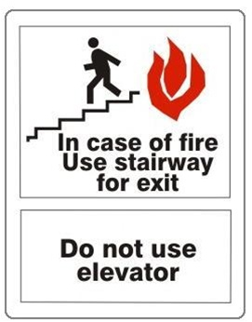
Fire – You should never use an elevator because it may break and you could get trapped in it.
- The stairs are a safe route because it is very unlikely that you would get trapped in them.

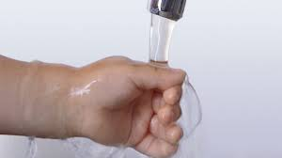
Burns/Sculds – You should always run COLD water on your hand after burning yourself.
- This will minimize the pain also.

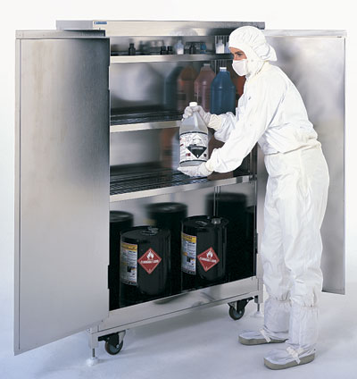

Chemicals – In this picture it shows that we should store chemicals in a separate projects
- This will make sure that the chemicals do not get in food.

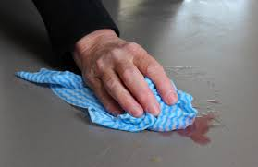
Slips/Trips/Falls – This picture shows that you should wipe up spills right away so no one trips or slips on it.
- You should never wait to wipe up spills because someone could slip on it.

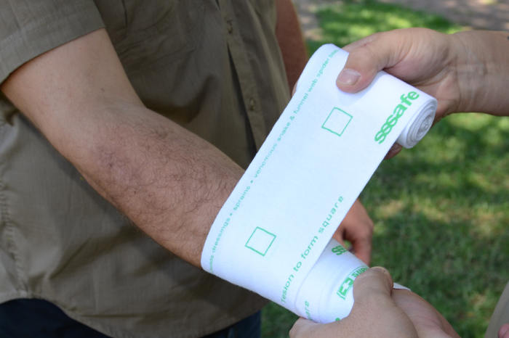
Cuts – You should wrap the cut in a bandage or wrap.
- You should also apply pressure to the cut.

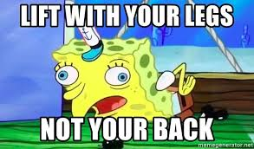

Heavy Lifting – You should lift with your knees not your back
- You should get help if something is to heavy for you.

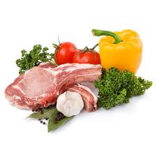

How to prevent food poisoning – You should never store raw meat with veggies.
- You should also use different cutting boards for meat and veg.

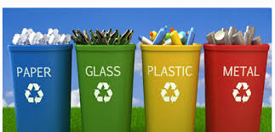
Waste management – Make sure everything you throw away goes in the right bin
- Double check that the thing you are throwing away goes in that bin.

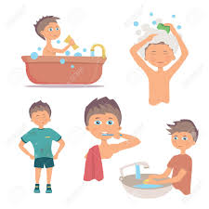
Personal hygiene – Make sure that you are clean before cooking food or going to work.
- Wash your hands frequently

