Float Your Boat Challenge
By: (Scott Helmhold)
Group Members: Scott, Brad, Anton
Science 10 Block: C

Problem: We need to make the boat hold the most pennies

Hypothesis: If buoyancy affects the boats buoyancy ability the boat will hold the most pennies because the straws with the marshmallows will make it float

Observations:
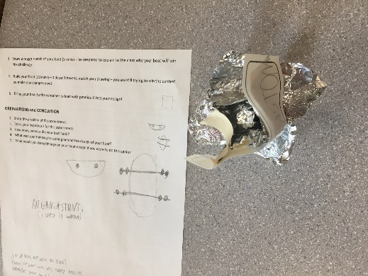
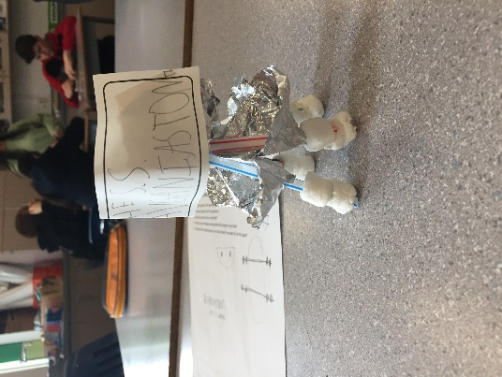
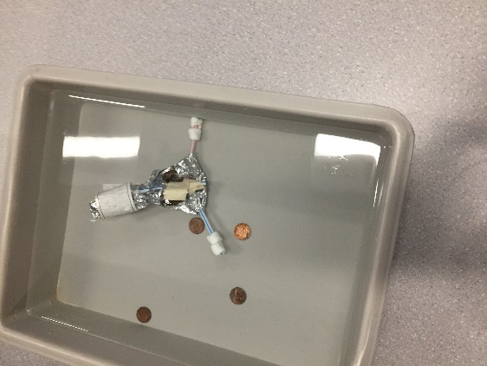

Results and Conclusions:
The boat held 7 pennies

The original thinking and reasoning behind the design was that the triangle would be a strong shape that would be able to hold lots of pennies

If the following challenge was repeated, to improve the boat design, the following changes would be made, we would make the walls of the boat higher because the when the winning boat that hold 80 pennies it was sinking slowly penny by penny but the high walls held the water out.

Upload this document to your Edublog and Tag your post “floatyourboatdurandsc10blk_” add your block letter “C or D”

