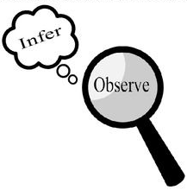
Observations and Inferences
Science 10 Name: BLK:

OBJECT | OBSERVATIONS  Words that describe the object | INFERENCES  Ie: Where might the object come from? Possible uses? Etc. | QUESTIONS YOU HAVE ABOUT THE OBJECT
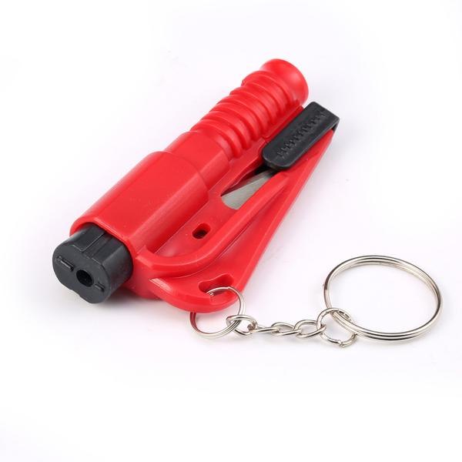  Red keychain thing | - Red  - Small  - Blade on the inside  - Pops when pushed down on | Seat belt cutter, and to break glass | - What does it do  - Where do you keep it  - How do you use it
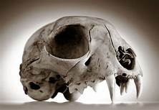  Skull | - Holes  - Made of bones  - Big jaw  - Lighter than it looks  - Dirty  - 17 teeth | - Carnivorous  - Lived in prehistoric ages  - Lived in grasslands | - What does it eat  - Where did it originate  - What color was it  - Does it have fur
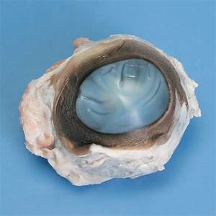  eyeball | - Wet  - Bluish  - Lots of tissue  - Optical nerve | - The animal was dead when it was cut out  - It is a cows eye | - What species of animal is this  - Where was this animal from  - What is the liquid
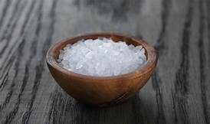  Salt of some sort | - White  - Small grains  - Smells like salt  - Hard | - Used for laundry detergent  - Made from salt | - What is it used for  - Where do you use it  - How do you use it  - What is it made from  - Where do you get it

Observations/Inferences Assignment Assessment
Name: _____________________
Ex: Excellent VG: Very Good G: Good S: Satisfactory IN: Improvement is needed
Criteria | IN | S | G | VG | Ex
The following is included
- All 4 Images included
Observations:
- A minimum of 5 detailed observations made
Inferences:
- Thoughtful and logical inferences made
Questions:
- 2 thoughtful and logical questions made
- Spelling/grammar
- Assignment was completed on time
/10

