Name: Savannah W | Date: feb 25 2020

How does the artifact you selected demonstrate strengths & growth in the communication competency?  In what ways might you further develop your communication competency? | Self-Reflection  Describe how the artifact you selected shows your strengths & growth in specific core competencies. The prompt questions on the left - or other self-assessment activities you may have done - may guide your reflection process.  I used communication in health for this unit because I learned how to refuse witch mean say no to the situation, negotiate ware to make a deal like can we play basketball in stand of drink and delay by saying maybe later, by doing an activity ware you get a card and write ether a refusal, negotiate and a delay on a card for what it is asking like come drink with us. We also got taught how to ask for help if you have an addiction. I also used communication by putting my hand up to answer question when she asked us in class. The last communication we used was we had to do a skit on alcohol in front of the class.  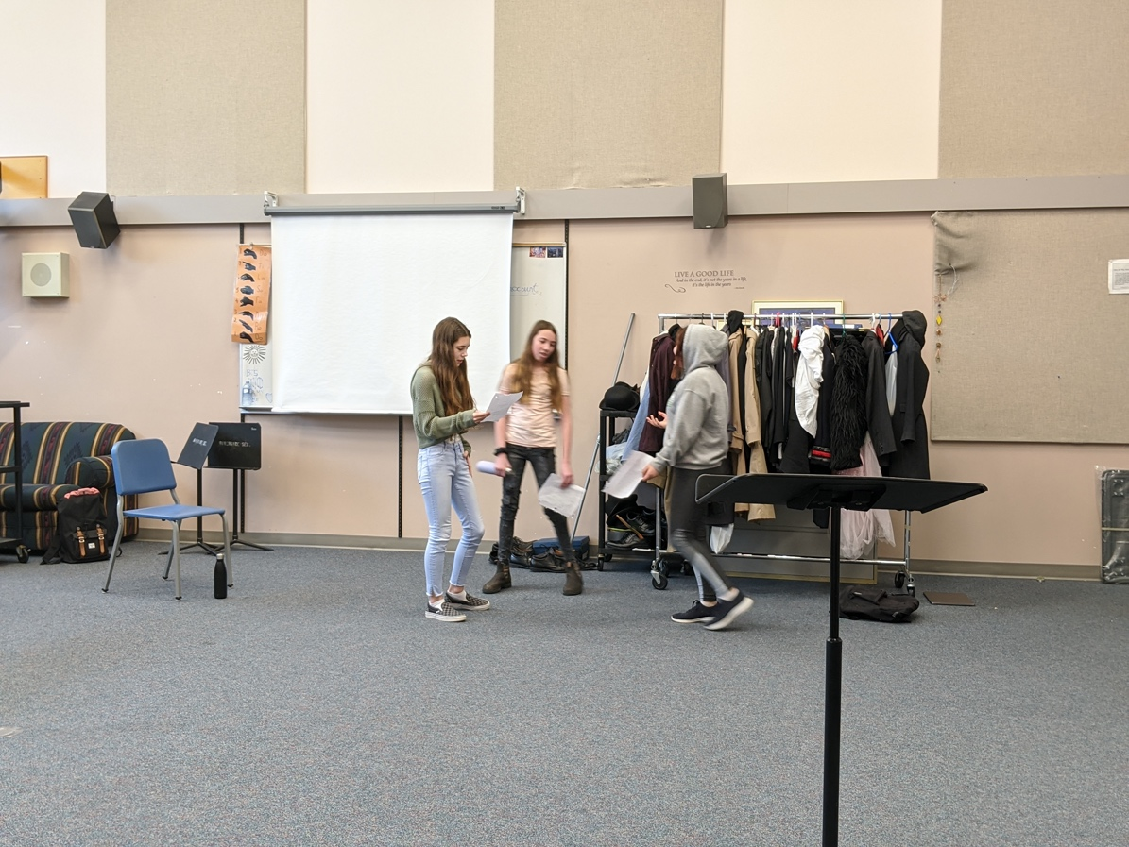

How does the artifact you selected demonstrate strengths & growth in the thinking competencies?

In what ways might you further develop your thinking competencies?

How does the artifact you selected demonstrate strengths & growth in the personal & social competencies?

In what ways might you further develop your personal & social competencies?

Publish Your Self Assessment
You will now attach and/or embed your self-assessment to the bottom of the blog post with the artifact you have chosen. You may choose to make this post private or public. After placing your artifact on a blog post, follow the instructions below.
- Categories - Self-Assessment
- Tags - Now tag your post using the tag that corresponds to the competency that you have written about. You can choose more than one. Please use lower case letters and be exact.
  - #creativethinkingcc
  - #communicationcc
  - #criticalthinkingcc
  - #socialresponsibilitycc
  - #personalidentitycc
  - #personalawarenesscc
- Use the Add Document button located at the top of your post page and embed your self-assessment at the bottom of your blog post.
- Publish

