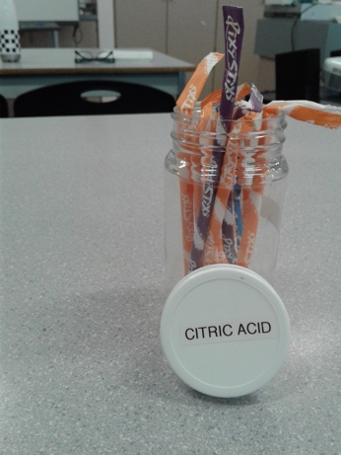
Purpose: To find the pH and concentration of citric acid in Pixi Stix.

Procedure:
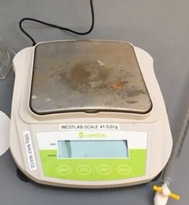
- Weight 5g of the solid.

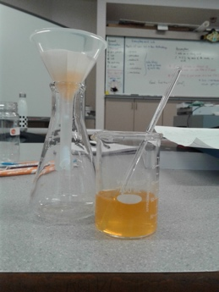
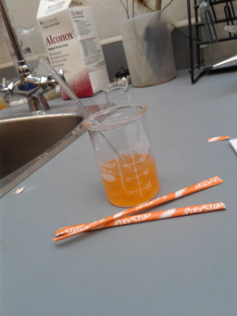
- Dissolve in 0.05L of water until solution.

- Add two drops of phenolphthalein.
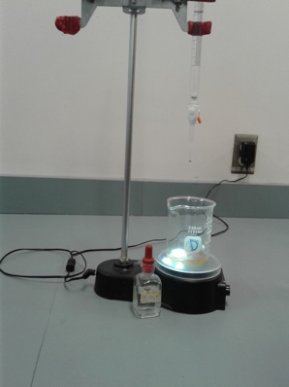
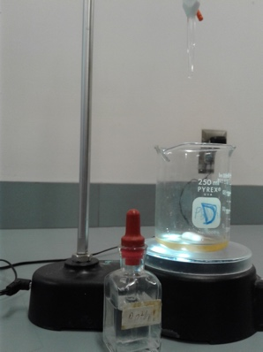
- Titrate 0.10M sodium hydroxide into 0.01L of acidic solution.
- Stop titrating once solution turns pink, indicating neutral pH.
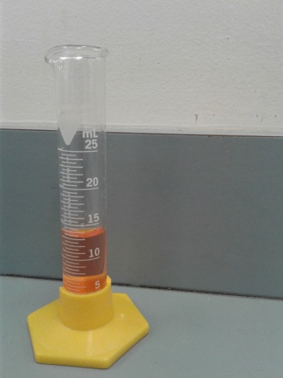
- Measure final volume of solution.
- Calculate final concentration of sodium hydroxide (M₂), giving the concentration of the citric acid.
- Use this value (M₂) to determine pH.
- Repeat two more times.
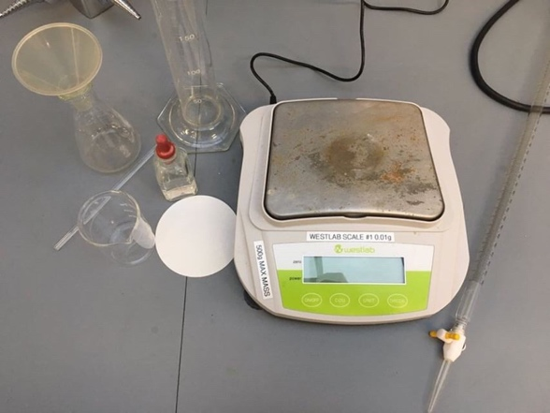
Materials:
- 2.5 Pixi Stix (5g)
- 0.05L water
- 0.04L sodium hydroxide
- Filter paper
- Pipette
- 2 graduated cylinders
- 2 beakers

Data:
Trial 1:
- 0.01L citric acid and water solution
- 0.003L of sodium hydroxide needed to neutralize solution
- Final volume: 0.013L
Trial 2:
- 0.01L citric acid and water solution
- 0.0057L of sodium hydroxide needed to neutralize solution
- Final volume: 0.0157
Trial 3:
- 0.01L citric acid and water solution
- 0.0043L of sodium hydroxide needed to neutralize solution
- Final volume: 0.0143

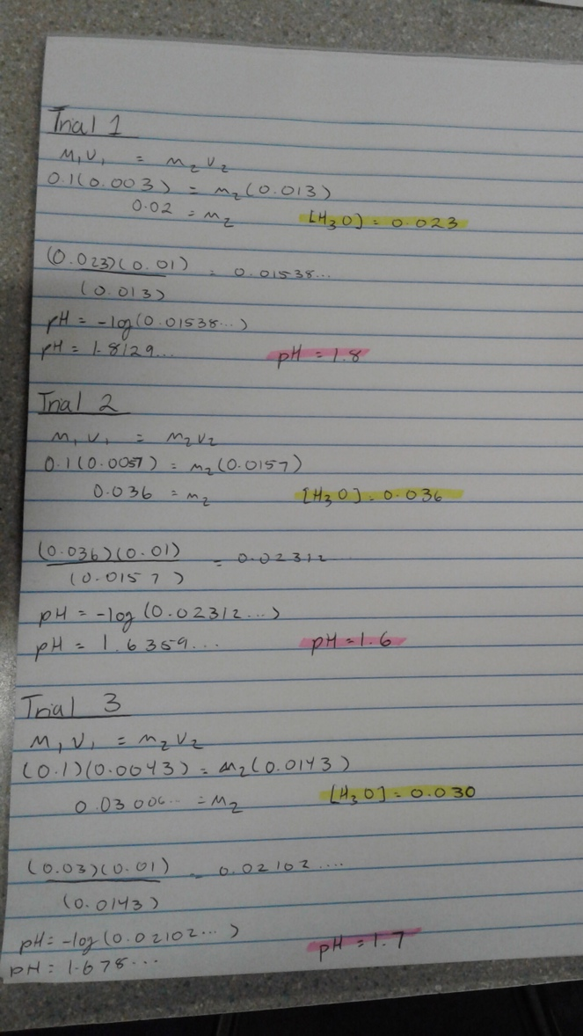
Calculations:
Conclusion:
By the end of this lab we understood that acids play a role in many aspects of our daily lives. We understood that for calculating the pH of a candy, we should dissolve it in water, and in the second step for getting rid of the unnecessary materials we must filter it. Also, phenolphthalein plays a big role in this lab, if it wasn’t available in the beaker, the colour of our solution couldn’t change from orange to pink. We used M1V1=M2V2 formula. In this case the M1 & V1 are the concentration and volume of the base (NaOH), and M2 & V2 are the concentration and volume of the citric acid (final product). Based on our data and [H3O+], it makes sense that the final pH will be between 1.5 and 2, as the pOH of the base is approximately 13.

