ELECTRICITY: GENERATION AND TRANSMISSION
If there’s one thing we regularly take for granted, it’s electricity. Sure, we get a small taste of what life was like before people learned how to harness energy to use in our homes, but power outages hardly ever last more than a few hours. At home, plugging in your phone or flipping on a light switch seems simple, but there’s a lot that goes into that small action. Our electricity has to come from somewhere, and millions of dollars are invested into keeping our cities lit every year. Unless you live in the middle of nowhere and have a couple dozen wireless generators, you are reliant on companies like BC Hydro that transmit electricity and power to our homes. So how do they do this?
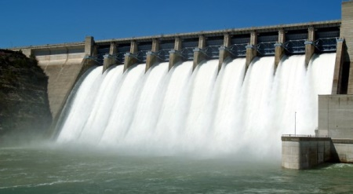
Citizens of Port Coquitlam have two sources for their electricity: Lake Buntzen and the Burrard Thermal plant. The former is used for hydroelectric generation, a process that produces about 95% of BC’s electricity. On Lake Buntzen is a hydro dam, and there is a reservoir behind it containing lots of potential energy. Water is kept behind the dam, and once that water begins flowing, that potential energy is transformed into kinetic energy. The kinetic energy goes down a massive pipe and hits a series of blades, thus becoming mechanical energy. This mechanical energy powers a turbine, which is connected to a generator. Once the turbine spins, the generator is thrown into action, turning mechanical energy into electrical energy.
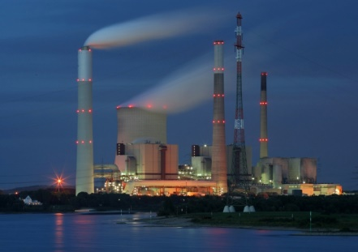
Another way of producing electricity is the use of fossil fuels at a thermal power station. Thermal power stations burn oil, natural gases, or coal to produce energy to spin turbines that produce the energy. The burning of these resources results in a lot of heat, which effectively turns water in a boiler room into steam, which spins the turbine. Like with the hydropower station, the turbine powers a generator that turns kinetic energy into electrical energy.
So now we have our electricity, but the job is not done. The generator uses very small amounts of voltage to produce electrical energy, but it takes thousands of volts to push that electricity to our homes. That’s where the Step-up transformer comes in. The step-up amps the voltage of the electricity to super high levels and decreases the current drastically, since the power rate must always stay the same. The electricity flows high-energy power lines over super long distances. Electrical plants are normally out of the way because if anything disastrous happens, you don’t want that anywhere near residential places. They are almost always protected by large towers to keep animals and humans away, and the transmission lines have insulators, so nothing can be accidentally shocked due to a power surge. Because of this, the electricity has to travel really far, and those power lines do the job.
However, once the electricity hits a town, it’s voltage is much too high to put into homes. The average voltage of the electricity before hitting a step-down transformer is about 500 000 kilovolts (kv). The step-down does the exact opposite of the step-up – it decreases the voltage and increases the current. The electricity then travels through more transmission lines to a distribution station, where the 60-138kv is lowered to about 25kv. By the time the electricity comes to our homes, the voltage is at only 240 volts, due to a series of pole transformers.
So now that you know about our two main sources of electricity, a decision must be made: which one is better? Let’s start with the thermal power stations. For one, it’s incredibly easy to have a thermal power station. Coal, oil, and natural gases are plentiful almost anywhere, and for desert countries with limited natural resources, thermal power stations are the best bet. They’re also very cheap considering how much energy they produce, which can be in the 5500 mega-watt range. However, thermal power stations are one of the largest contributors to fossil fuel levels, which increase pollution. The energy produced is also non-renewable and can potentially be very dangerous due to highly flammable materials, so the relatively cheap to build plant must invest thousands of dollars to ensure that there are enough workers to dispose of the waste properly.
Hydroelectric plants are much more eco-friendly, and cheaper to operate. Water is considered a renewable resource, so when water is used to spin the turbine, it goes back into the water cycle. It’s also incredibly efficient, at its average rate being 90%. The cost to maintain it is also fairly cheap due to incredibly small risks of flooding, and the lack of use of dangerous materials. However, it is fairly expensive to build and cannot be used unless there are massive amounts of water. But in Port Coquitlam, we have plenty of water to go around.
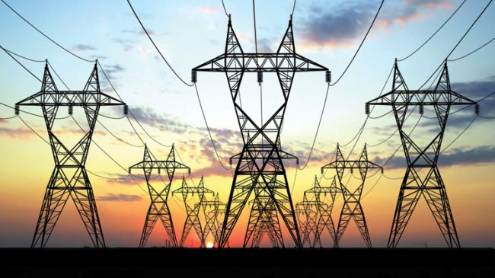
Electricity is expensive. It’s complicated, and more often than not, can be dangerous to work with. Thermal power stations are still used regularly everywhere, including the 99 nuclear power plants in the USA. Fossil fuels are being burned at exceedingly high amounts, contributing greatly to global warming simply because we demand so much power. So now that you know how our electricity is produced and how much work is put into powering the light in your kitchen, maybe you’ll become more conscious about your energy use. Try unplugging your charger when nothing is in use and turning off the lights when you leave the room, or it’s bright enough outside. Electricity is a luxury – millions of people all over the world don’t have access to constantly powered lightbulbs or a computer. We shouldn’t take it for granted.

Sources:
Sheets given in class
- https://www.bchydro.com/energy-in-bc/our_system/generation/electric_generation.html
- http://science.howstuffworks.com/environmental/energy/hydropower-plant3.htm
- http://www.bbc.co.uk/bitesize/standard/physics/energy_matters/generation_of_electricity/revision/1/
- https://en.wikipedia.org/wiki/Thermal_power_station

