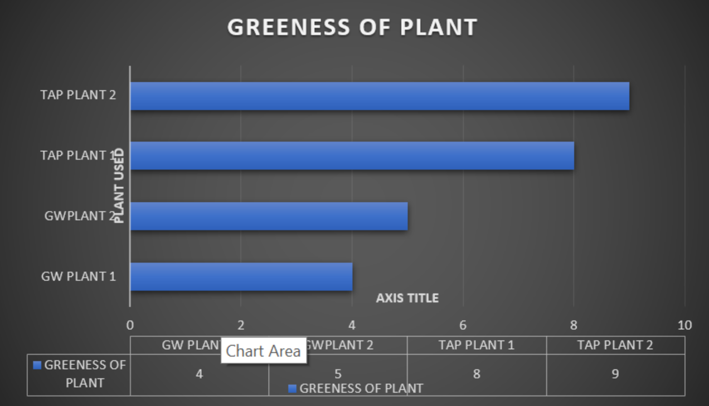

Colour Scale | 0-2 | 3-4 | 5-6 | 7-8 | 9-10
Leaf Colour

