DNA Replication and Protein Synthesis Modelling
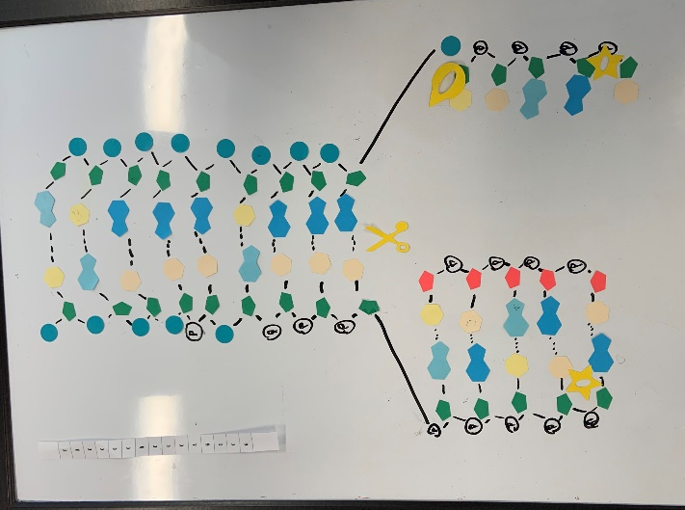
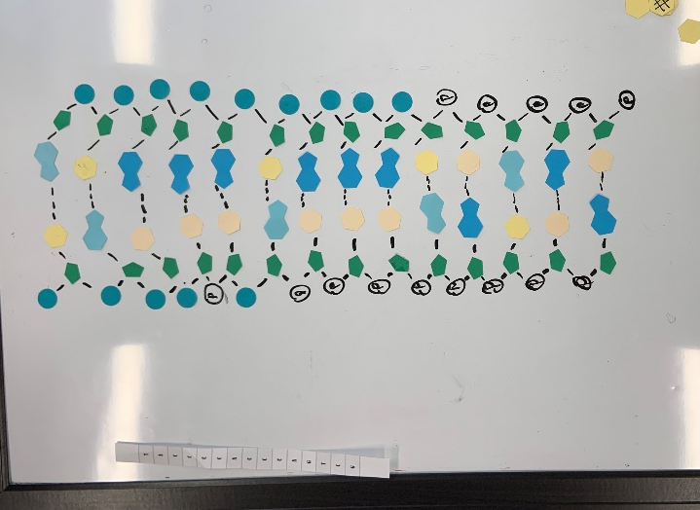
Replication:
DNA strand DNA strand Unzipped

1. Explain the structure of DNA – use the terms nucleotides, antiparallel strands, and complementary base pairing.
DNA, or deoxyribonucleic acid, is a double-stranded molecule that stores genetic information in all living organisms. Its structure consists of repeating units called nucleotides, which are composed of a sugar molecule, a phosphate group, and a nitrogenous base.
The sugar molecule in DNA is called deoxyribose. The phosphate group is attached to the 5' carbon of the sugar molecule, while the nitrogenous base is attached to the 1' carbon.
The four nitrogenous bases in DNA are adenine (A), guanine (G), cytosine (C), and thymine (T). The bases pair up in a specific pattern through hydrogen bonds to form the "rungs" of the DNA ladder. Adenine pairs with thymine, and guanine pairs with cytosine, known as complementary base pairing.
The two nucleotide strands in DNA are antiparallel or run in opposite directions. One strand runs from 5' to 3', while the other runs from 3' to 5'. The direction of the strands is determined by the orientation of the sugar molecule, which has a free 3' hydroxyl group on one end and a free 5' phosphate group on the other end.
The double helix structure of DNA is formed when the two nucleotide strands twist around each other. The nitrogenous bases form the rungs of the helix, while the sugar-phosphate backbone forms the sides. The hydrogen bonds between the complementary base pairs hold the two strands together, providing stability for the double helix structure.

2. When does DNA replication occur?
The DNA process is when the cells synthesize a copy of DNA is the cell's nucleus. Before the cell divides it must copy or “replicate” its genome so that each daughter cell ends up with its own complete genome. DNA replication occurs during the “S Phase” and is the period in which the cell replicates its genetic content during the cell cycle before mitosis or meiosis and is the product of synthesis or replication.

3. Name and describe the 3 steps involved in DNA replication. Why does the process occur differently on the “leading” and “lagging” strands?
Firstly, the DNA will unzip, which is when the unwinding of the double helix takes place. Additionally, the two strands of DNA will separate from one another while the hydrogen bonds that were formed between bases are broken. Secondly, complementary base pairing occurs where new nucleotides come into place to pair with the bases of the appropriate template strand of DNA. These new nucleotides are constantly roaming around the nucleoplasm. Finally, adjacent nucleotide bonding occurs where sugar-phosphate bonds are formed between adjacent nucleotides. These nucleotides come from the new strand which is required in order to complete the molecule. Each new strand of DNA has one old strand and one new strand which is called semi-conservative replication. This makes sure that there will be an accurate replication of the parent molecule. In the end, the product of replication by one DNA molecule is two complete double-stranded DNA molecules. Each molecule has one new strand and one old or original strand which had the role of being a template for replication.
The reason that the process occurs differently on the “leading” and “lagging” strands is because of the antiparallel orientation the two chromosomal DNA strands have. The leading strand is replicated in a processive way for the most part while the lagging strand is synthesized in short fragments.

4.Today’s modelling activity was intended to show the steps involved in DNA replication. What did you do to model the complementary base pairing and joining of adjacent nucleotides steps? In what ways was this activity well suited to showing this process? In what ways was it accurate?
We were given a strand of DNA and we had to replicate the strand. Once we got to a certain point, we “unzipped” the strand of DNA. Once the DNA was unzipped, we could model the complementary base pairing and attach nucleotide where it belonged creating two strands. The model we made showed a simple understanding of how DNA replicated. This model could be accurate as sometimes incorrectly pairing one nucleotide with another.

Transcription:
Transcription from DNA strand to RNA strand
- How is mRNA different than DNA?
To start off, DNA is built up of deoxyribose sugar. On the other hand, mRNA is built up of ribose sugar. In terms of nitrogenous bases, DNA consists of thymine as one of the pyrimidines and mRNA has uracil instead of thymine as its pyrimidine base. DNA is in the nucleus and mRNA spreads into in the cytoplasm following the process of synthesis. The mRNA will move the codons that are needed to make a protein in protein synthesis but DNA does this differently. It transfers codons that are copied from DNA by the process of transcription. Lastly, DNA is double stranded while mRNA is single stranded in terms of shape.

- Describe the process of transcription
The process of transcription takes place in the nucleus. It uses the DNA to make a template for RNA also known as mRNA molecule. During the transcription process, an RNA stand is made to complement a DNA strand. Transcription starts when an RNA polymerase binds to a promoter sequence near the beginning of a gene through helper proteins. Transcription occurs when there is a need for a gene at a certain time or at a certain tissue. When transcription occurs it usually only copies 1 strand of DNA and is called a template strand. When in transcription the RNA molecules come together and produce a single-stranded messenger RNA (mRNA).

- How did today’s activity do a good job of modelling the process of RNA transcription? In what ways was our model inaccurate?
It shows how the RNA strand is created from a template strand and how RNA is its own copy of a gene’s DNA sequence. Our model did a great job depicting the accuracy of the process of RNA transcription as the model shows how the ribosomal subunit goes across the template strand making complimentary base parings one by one until 3 of the nucleotides create a stop codon, where the m-RNA creation is stopped. Our model stops the process when we hit the stop codon.

Translation:

1. Describe the process of translation: initiation, elongation, and termination.
The process of translation is when a cell uses the genetic information in m-RNA to make proteins. The information m-RNA carries tells cells how to link amino acids together to make proteins. Translation occurs in three steps, initiation, elongation, and termination. During initiation, a ribosome attaches itself to t-RNA which carries methionine they then bind to m-RNA at the start codon AUG. During elongation, the RNA strand gets longer as new nucleotides get added. The final step of translation is termination, where one of the three stop codons will arrive at the A site of the ribosome. No molecules from t-RNA bind to the stop codons so the peptide chain is released into the cytoplasm.

2. How did today’s activity do a good job of modelling the process of translation? In what ways was our model inaccurate?
It was a good model because it showed the fundamental steps of how the process of translation occurs and how each amino acid is created based on the mRNA strand that was transcribed from the strand of DNA. The way this was inaccurate was because mRNA translation occurs fast about 40 amino acids per second whereas we were doing one amino acid per 10 seconds.

