
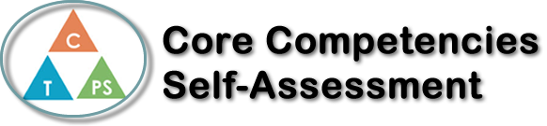
Name: Sahar Ansari | Date: 2020/02/26

  X  How does the artifact you selected demonstrate strengths & growth in the communication competency?  In what ways might you further develop your communication competency? | Self-Reflection  Describe how the artifact you selected shows your strengths & growth in specific core competencies. The prompt questions on the left - or other self-assessment activities you may have done - may guide your reflection process.  This semester in P.E we started our second health unit on substance use and addiction to drugs. While going through the 5 lessons in this unit it helped me grow in my positive personal, cultural identity, and communication competency. Going through each lesson I was able to understand how important my personal values and choices are, seeing that many people who are addicted to drugs were peer pressured, it helped me to understand that my own values should be above anyone else wants and needs. When watching videos of adults wishing they stood strong to their choice I believe that I should learn from their experience to stay strong to my beliefs and choices. In addition, to growing in positive personal and cultural identity CC I showed growth in the communication competency as well. During this unit I was able to connect with others when getting to know their thoughts and ideas, while engaging with them in activities based on our thoughts on substance abuse. Secondly, as a group we collaborated to carry out the instructions our teacher gave and we presented the information we had learned throughout the weeks through a play, then after writing 4 paragraphs to reflect on our experience. In conclusion spending my second semester of P.E to start a health unit on substance abuse helped me to grow on my core competencies in may beneficial ways.


How does the artifact you selected demonstrate strengths & growth in the thinking competencies?

In what ways might you further develop your thinking competencies?

X

How does the artifact you selected demonstrate strengths & growth in the personal & social competencies?

In what ways might you further develop your personal & social competencies?

Publish Your Self Assessment
You will now attach and/or embed your self-assessment to the bottom of the blog post with the artifact you have chosen. You may choose to make this post private or public. After placing your artifact on a blog post, follow the instructions below.
- Categories - Self-Assessment
- Tags - Now tag your post using the tag that corresponds to the competency that you have written about. You can choose more than one. Please use lower case letters and be exact.
  - #creativethinkingcc
  - #communicationcc
  - #criticalthinkingcc
  - #socialresponsibilitycc
  - #personalidentitycc
  - #personalawarenesscc
- Use the Add Document button located at the top of your post page and embed your self-assessment at the bottom of your blog post.
- Publish

