**Sahar Ansari Burning Question 2019/11/01**

Burning Question

How did child labour affect the children’s lives during the Industrial Revolution?

Guiding Questions?

What were the conditions like at their job?

How did the factories affect their health?

What where the living conditions?

(images , n.d.; Hine, 2015)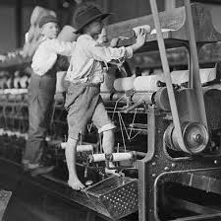

The factories children worked at made a big impact on their health, mentally and physically. The mines they worked at had bad ventilation which they developed lung disease from, and gave many children breathing problems. Children had to carry coal which affected their health physically, the heavy weight of the coal caused their growing bodies to deform. One of the deformities were “knock-knees” where children knees would become so weak, they turned inwards, causing them to lose 12 inches of height because of it. This deformity would happen when they stood on their feet for a long period of time. The job “Breakers” affected their health because it was a job were boys who were as young as 8 years old sorted coal from rock and slate, this job exposed lots of dust, that was so dense it obstructed their vision, as well as getting into their lungs, and casing lung disease. When working at factories they got fed there to the children didn’t have enough to eat, and lacked healthy foods, which gave them the health condition malnutrition.

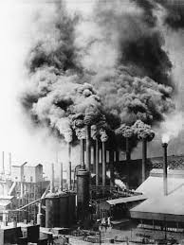

Child Labour during the Industrial Revolution was when children as young as four years old worked long shifts from around 12-16 hours long doing jobs such as working on machines in the factory, breaking up coal at mines, pulling and pushing full tubs of coal for 2 kilometers, and chimney sweeping. The children were hard working and did the same amount of work as adults but got paid around 10-20 percent less, businessmen liked to hire them because they were obedient and accepted the punishments easily instead of resisting like adults. The children fit into small spaces and had small hands which they could fit into the machines when they were jammed or clogged with thread which would higher the amount of production goods. Working on the high-powered machines with very little training, caused many injures, they lost limbs and fingers, and most children were not tall enough, so they stood on the machine, where some easily lost balance and fell off. Most children wore clothes sizes too big for them which easily got pulled into the machine along with themselves. When children got injured, from working at the factories they got no compensation, and were to just stay home because they could no longer work.

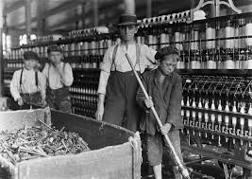

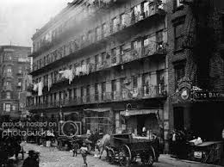 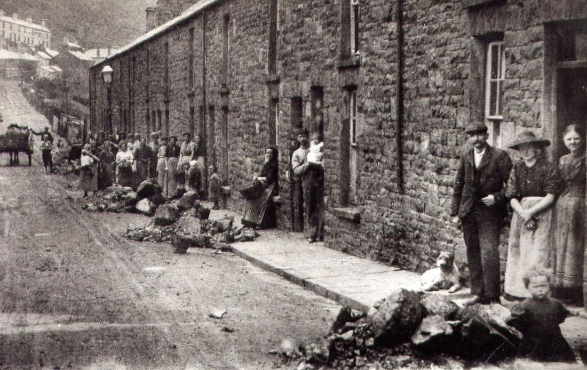

Before the industrial revolution people lived on farms with their families and had home businesses. Once the factories began, home businesses were shut down and people moved to the city and looked for jobs. When more and more people came to work at factories, cities became very overcrowded and disease ridden. One room in the apartment was shared with around 9 people, because of how close people were to each other it caused diseases to spread easy. Constructers rapidly built apartments side by side connected to each other, without leaving any space in between the homes except for the front entrance. The apartments were cheap to make and were poorly built, it was an inexpensive way for wealthy factory owners to profit. The apartments lacked basic features such as windows and proper ventilation. Most homes were built without running water and sanitation, many people were unable to properly bathe, and they suffered from poor hygiene. Since most homes did not have running water or sanitation, people resorted to dumping their filth and waste into the street, because of this outside of people’s apartments pits were made for people to dump their waste, these pits could get emptied for an additional fee. The pits and waste made the streets incredibly dirty places to live as well as allowing communicable disease to easily spread to one another. Outside the apartments were “slums” slums were people who couldn’t afford to rent an apartment, they lived alongside the apartments, and near the pits, they caught the diseases the easiest because they lived with no sanitation, and along the polluted pits.

# Works Cited

dore, G. (2009, april 20). *permaculturenews*. Retrieved from permaculturenews.org: https://permaculturenews.org/2009/04/20/an-industrial-revolution-like-no-other/

*ducksters*. (2014). Retrieved from ducksters.com: https://www.ducksters.com/works_cited/industrial_revolution.php

Hine, L. (2015, feburary ). *spartcaus educational*. Retrieved from spartcaus-educational.com: https://spartacus-educational.com/IRbrown.htm

*history crunch*. (n.d.). Retrieved from historycrunch.com: https://www.historycrunch.com/child-labor-in-the-industrial-revolution.html#/

*history media*. (n.d.). Retrieved from stmuhistorymedia: https://stmuhistorymedia.org/child-labor-in-the-coal-mines/

*histroy crunch*. (2016, januray 5). Retrieved from historycrunch.com: https://www.historycrunch.com/living-conditions-in-industrial-towns.html#/

*images* . (n.d.). Retrieved from https://www.google.com/url?sa=i&source=images&cd=&ved=2ahUKEwi85a7CkMjlAhVWrZ4KHXYmBXkQjRx6BAgBEAQ&url=https%3A%2F%2Fwww.historycrunch.com%2Fchild-labor-in-the-industrial-revolution.html&psig=AOvVaw0ycQS6fM1kj57wiC3How4B&ust=1572573709933056

images, g. (2010, august 2). *independet*. Retrieved from independet.co.uk: https://www.independent.co.uk/news/uk/home-news/revealed-industrial-revolution-was-powered-by-child-slaves-2041227.html

images, w. g. (2019, january 5). *history*. Retrieved from history.com: https://www.history.com/news/second-industrial-revolution-advances

*industrial revolution group buddies*. (n.d.). Retrieved from industrialrevolutiongroupbuddies.weebly.com: https://industrialrevolutiongroupbuddies.weebly.com/education.html

*pintrest* . (2019, march). Retrieved from pintrest.com: https://www.pinterest.ca/pin/329888741447350821/

*squarespace*. (n.d.). Retrieved from static1.squarespace.com: https://static1.squarespace.com/static/57b73fcce3df285e48e1d0b2/t/5bd32aeee4966b883f31da3c/1540565743049/Physical+Deformities+article.pdf

*stmuhistorymedia*. (2017, april 28). Retrieved from stmuhistorymedia.org: https://stmuhistorymedia.org/child-labor-in-the-coal-mines/

writers, H. C. (2016, January 5). *history crunch*. Retrieved from Historycrunch.com: https://www.historycrunch.com/living-conditions-in-industrial-towns.html#/

Writers, H. C. (2016, october 5). *History Crunch*. Retrieved from Historycrunch.com: (images , n.d.)

**Crosswords 1 textbook page 144-149**

Crosswords 2 page 241, 249-25