
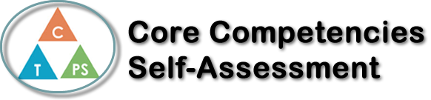
Name: Sabrina Sharifzada | Date:

  How does the artifact you selected demonstrate strengths & growth in the communication competency?  In what ways might you further develop your communication competency? | Self-Reflection  This semester has been very different due to the global pandemic, which has affected us especially in Calculus class. When I first started the remote learning, it was very difficult to make sure I do not miss any meetings. However, I learned to make a schedule to be on track with all my classes. Social responsibility was a skill that we used a lot during the remote learning process. I always made sure to be on track with the lessons and the homework and do my best to always to prepare as much as I could for the tests and quizzes. It would sometimes get very difficult to stay on track all the time because there are so much more distractions at home. The recorded meetings were something that helped me a lot because when I could not join a meeting, I always made sure to check the recording to complete the notes. Personal awareness was also another competency that I used throughout this process. I became more aware of how I study and learn best throughout the course. Overall, calculus class prepared me very well for next year even though it was mostly online.


How does the artifact you selected demonstrate strengths & growth in the thinking competencies?

In what ways might you further develop your thinking competencies?


How does the artifact you selected demonstrate strengths & growth in the personal & social competencies?

In what ways might you further develop your personal & social competencies?

Publish Your Self Assessment
You will now attach and/or embed your self-assessment to the bottom of the blog post with the artifact you have chosen. You may choose to make this post private or public. After placing your artifact on a blog post, follow the instructions below.
- Categories - Self-Assessment
- Tags - Now tag your post using the tag that corresponds to the competency that you have written about. You can choose more than one. Please use lower case letters and be exact.
  - #creativethinkingcc
  - #communicationcc
  - #criticalthinkingcc
  - #socialresponsibilitycc
  - #personalidentitycc
  - #personalawarenesscc
- Use the Add Document button located at the top of your post page and embed your self-assessment at the bottom of your blog post.
- Publish

