
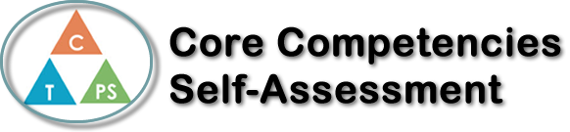
Name: Sabrina Sharifzada | Date:

  How does the artifact you selected demonstrate strengths & growth in the communication competency?  In what ways might you further develop your communication competency? | Self-Reflection  Remote learning really challenged everyone to use our personal awareness core competency. In Spanish class I did very well I made sure to attend all the meetings. I had to become aware of all the meeting times and make sure I completed the homework and the projects on time. Remote learning really forced me to become more aware and discover new study techniques and made sure I use all the different resources to be successful. I really appreciated that Ms. Lotter gave access to PowerPoints and notes to help us complete assignments. Overall, I did my best in Spanish class and got great results in the end.


How does the artifact you selected demonstrate strengths & growth in the thinking competencies?

In what ways might you further develop your thinking competencies?


How does the artifact you selected demonstrate strengths & growth in the personal & social competencies?

In what ways might you further develop your personal & social competencies?

Publish Your Self Assessment
You will now attach and/or embed your self-assessment to the bottom of the blog post with the artifact you have chosen. You may choose to make this post private or public. After placing your artifact on a blog post, follow the instructions below.
- Categories - Self-Assessment
- Tags - Now tag your post using the tag that corresponds to the competency that you have written about. You can choose more than one. Please use lower case letters and be exact.
  - #creativethinkingcc
  - #communicationcc
  - #criticalthinkingcc
  - #socialresponsibilitycc
  - #personalidentitycc
  - #personalawarenesscc
- Use the Add Document button located at the top of your post page and embed your self-assessment at the bottom of your blog post.
- Publish

