
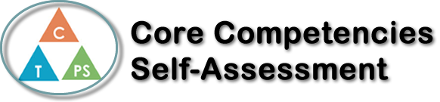
Name: Sabrina Sharifzada | Date:

  How does the artifact you selected demonstrate strengths & growth in the communication competency?  In what ways might you further develop your communication competency? | Self-Reflection  During these very unprecedented times, the core competency that was most used was personal awareness. Remote learning forced me to become more aware about how I learn best and allowed me to discover different study techniques. Remote learning also forced me to be more aware of due dates and meeting times because there was no one to remind us all the time. It was also my responsibility to learn because I could have easily skipped all the lessons; however, I was aware of my goals and I knew that if I wanted to end high school strong, I needed to continue and work hard. The quizzes really did help with forcing me to be on track when I did fall a little behind. The recorded lessons were also very helpful when we could not participate in a meeting. The recorded lessons really allowed me to study the topic in depth and I could re watch it and as many times I wanted. Overall, I think that I ended chemistry very well despite the challenges and the new learning style we had to adapt to.


How does the artifact you selected demonstrate strengths & growth in the thinking competencies?

In what ways might you further develop your thinking competencies?


How does the artifact you selected demonstrate strengths & growth in the personal & social competencies?

In what ways might you further develop your personal & social competencies?

Publish Your Self Assessment
You will now attach and/or embed your self-assessment to the bottom of the blog post with the artifact you have chosen. You may choose to make this post private or public. After placing your artifact on a blog post, follow the instructions below.
- Categories - Self-Assessment
- Tags - Now tag your post using the tag that corresponds to the competency that you have written about. You can choose more than one. Please use lower case letters and be exact.
  - #creativethinkingcc
  - #communicationcc
  - #criticalthinkingcc
  - #socialresponsibilitycc
  - #personalidentitycc
  - #personalawarenesscc
- Use the Add Document button located at the top of your post page and embed your self-assessment at the bottom of your blog post.
- Publish

