February Reflection

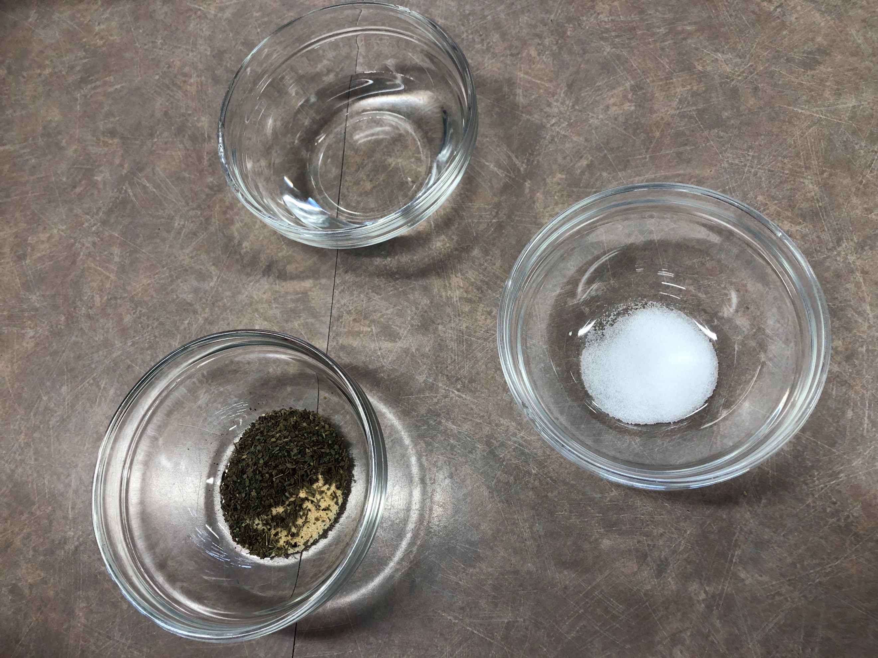
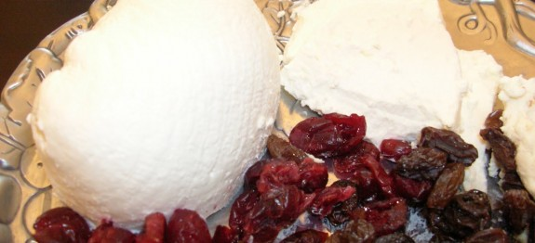
This month we did a lot of labs and I had couple of favourite labs, but the one I chose to reflect on is the DIY cheese. The reason why I chose the DIY Cheese is because I like cheese. I also chose to reflect on this recipe because in Afghanistan they make cheese using a similar method. In Afghanistan, we call this Keshmish Paneer translating to Raisins and Cheese which they eat as a dessert with tea. The only difference is that we also use yogurt and/or lemon juice to curdle the milk, since both are acidic. The taste is a little different because Keshmish Paneer is a little fresher tasting as we don’t use buttermilk and doesn’t have an acidic smell. However, the DIY Cheese had a little bit of a sour taste from the buttermilk and it had a vinegar like smell. Unlike the DIY cheese, we don’t add any spices to Keshmish Paneer as we eat it with raisins and tea. Personally, I really did enjoy the lab and I really liked how it was in partners because you got to more work to do. Me and Huda worked really well in this lab and the end product turned out the way we hoped. Since the procedure is like Keshmish Paneer I had experience and I knew how to do everything. I would definitely do this at home and see how my family likes it with spices inside. The only thing that I would change is the proportions to make more cheese. I would also like to experiment by adding walnuts and nuts into the cheese instead of the spices. Overall, I think that this was a really fun lab and probably my favourite out of all the labs we had done so far.

