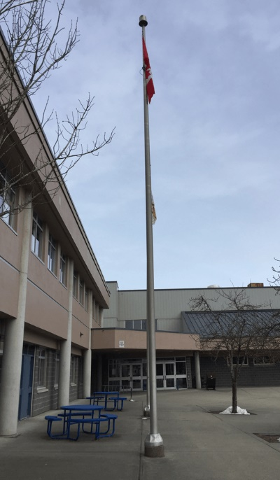
(Summary) USING TRIGONOMETRY TO MEASURE A FLAGPOLE!
Thursday December 3rd, 2020
The Challenge/Objective: The task at hand was to calculate the height of a flagpole using only two angles and one measurement to determine the height of a large object (the flag pole) using trigonometry.
On this beautiful Thursday afternoon, we had to measure the height of a flagpole by using trigonometry. We measured ourselves then compared it to the flagpole, then we measured the angle, from our eye level to the top of the flag. Once we got all the measurements, we then used the tangent ratio to find the height of the flagpole.
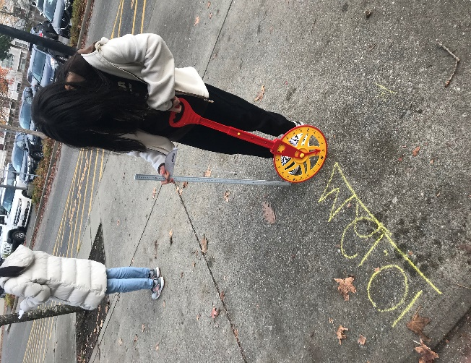
My partner, Angela and I started by measuring the height from the ground to my eyes. We would add this number at the end. We then used a clinometer to discover the angle of depression from my eyesight to the top of the flagpole. And finally, we measured the distance from which I stood to the base of the flagpole. Since we had two pieces of information, an angle and one length of the triangle, we had enough information to determine all remaining aspect of the triangle we had created from the flagpole. We determined that the flagpole is 10.4 meters. We had to take into account the fact that our equipment might not have been adequate enough to get completely accurate results. We think this is due to the resources we had access to and the time we had to properly measure every aspect of this experiment. We were able to find the height of the flagpole using a baseline and an angle. We had two pieces of information which allowed us to conduct this experiment. We found the tangent of the angle and multiplied that by our baseline length to get 8.8 and finally we added the height from the ground to my eyes to get the complete height of the flagpole.
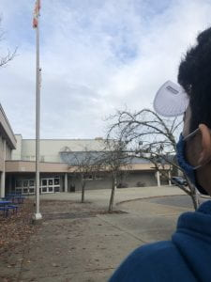
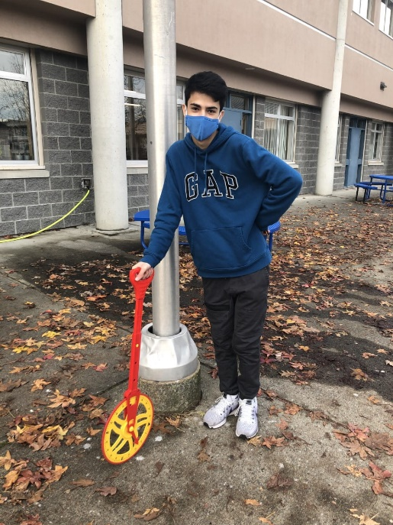
Data, Considerations, Tools, Applications
While doing this lab we used three main tools to aid our measurements including; a trundle wheel, a clinometer, and a meter stick. As we do not have access to precise measurement instruments, we had to do the best with what we had trying to take the most precise measurements we could. There are some aspects, however, that we must take into consideration before measuring. The slant of the ground made it difficult to keep the trundle wheel rolling perfectly on the ground at all times, possibly making our measurements slightly differ from reality. When looking through the clinometer we must decide whether we consider the cap at the top of the flagpole part of the structure and height of the pole or if we look lower towards where the pole meats the capper, making our angle different from another group. That group that we compared with may or may not have also accounted for the length of the flags base which may make our answers differ. Since we were outside, our measurement using the meter stick to see how tall Angela was until her eye may have also been inexact however, we tried our best with the materials and options we had available. Once I we had our measurements, we were able to use Tangent, as we had the adjacent sides measurement, the POR angle to Tangent to receive our ratio and the x to represent the length we needed to find.
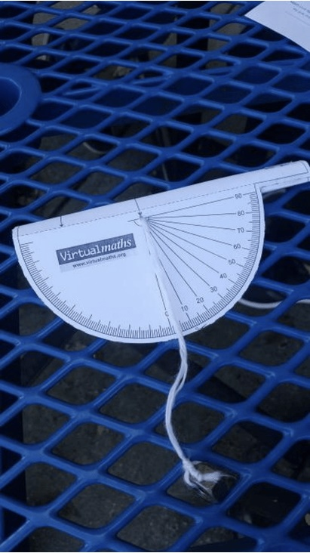
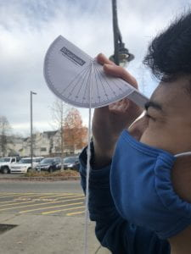
Trigonometry can help determine measurement which would be otherwise difficult to measure as you can use data that you are able to determine to find lengths and angles that are hard to determine otherwise. For example, in his experiment we were trying to determine the height of a flagpole which was super high therefore without trigonometry we would not be able to measure its height. Instead, we used the bottom length and angle of elevation to help determine the height as we only needed a few variables to help us find the missing ones.
Final Thoughts
Overall, I believe this lab was a success! I had a great time measuring and learning how to use the different tools that we used to measure and calculate the angle. I appreciated being outdoors and it really put into perspective how our classroom learning of trigonometry could be applied outside the classroom. This experiment was very interesting as it revealed the different ways we can use trigonometry in everyday life and that triangles are all around us.
