**Possible Written Question for Final Exam**

**Solve each equation below: Do not use any type of calculator.**

**1.  Give answer as an exact value.**

**2.  Give domain restrictions and state any extraneous roots**

**3.  Where  Give answers as exact values where possible.**

**4. Find the exact value of **

**5.  Give domain restriction as well.**

**6.  Give: amplitude ____ mean____ maximum____ minimum ____ period_____ phase shift and direction___________ Length of one-quarter period_______ Graph the function two full periods on the back of this sheet.**

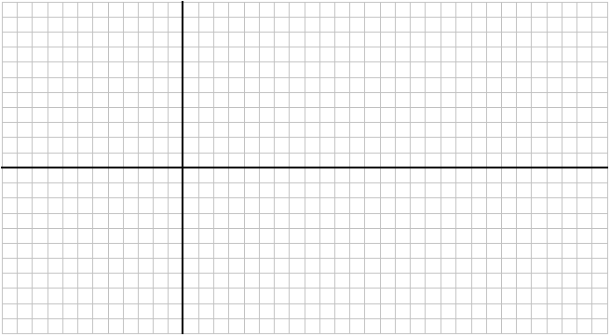

**Answers:**