Due Date: January 4th, 2019
For this task, you will create a Holiday card that includes a self portrait of yourself using equations of functions and relations and the website http://www.desmos.com. Make sure you create an account on desmos before you start, so that you work is saved. You will then write a post on your Edublog summarizing your creative process and tag it as a core competency reflection.
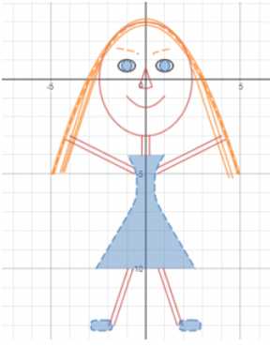
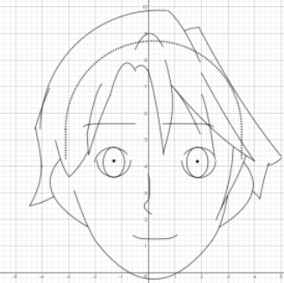
Portrait examples from Ms. McArthur’s grade 10 students.

Incomplete Holiday Card Incomplete Holiday card with axis and grid turned off
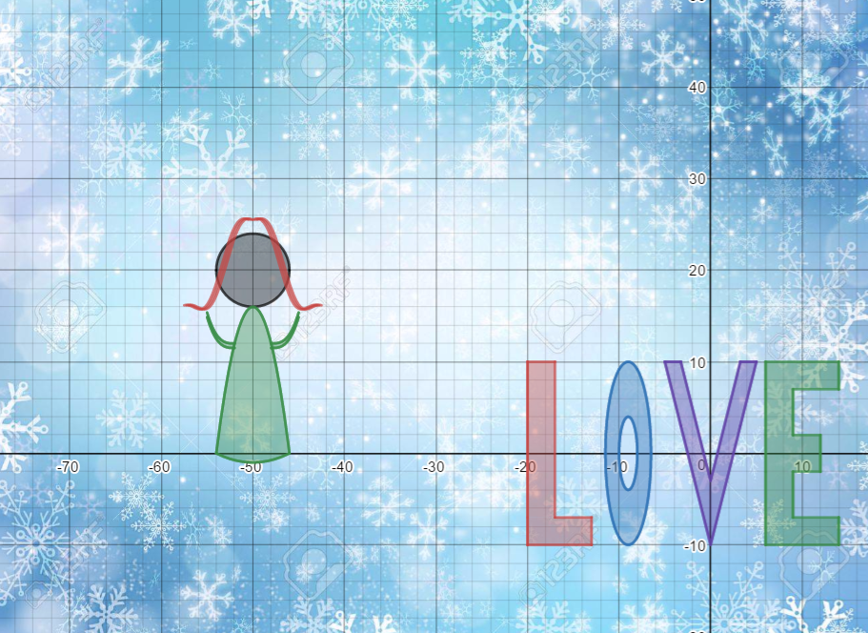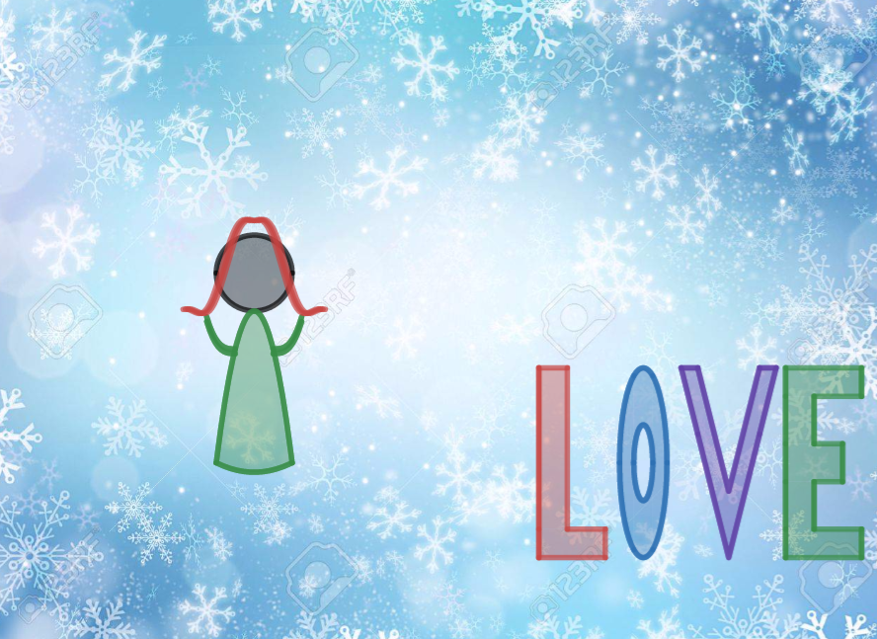
https://www.desmos.com/calculator/geifgb59je
You may use as many different functions and relations as you need however, you must choose at least one function from each of following 6 types of functions we have covered this year: Polynomial, Rational, Radical, Trigonometric, Exponential and Logarithmic to create the shapes for your card:
- You must demonstrate a clear understanding of transformations of functions and function notation. For example in the Holiday card above the hair was created using translations and reflections of the same function as shown below left.
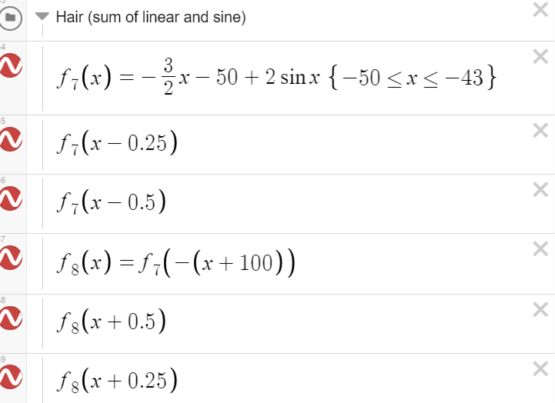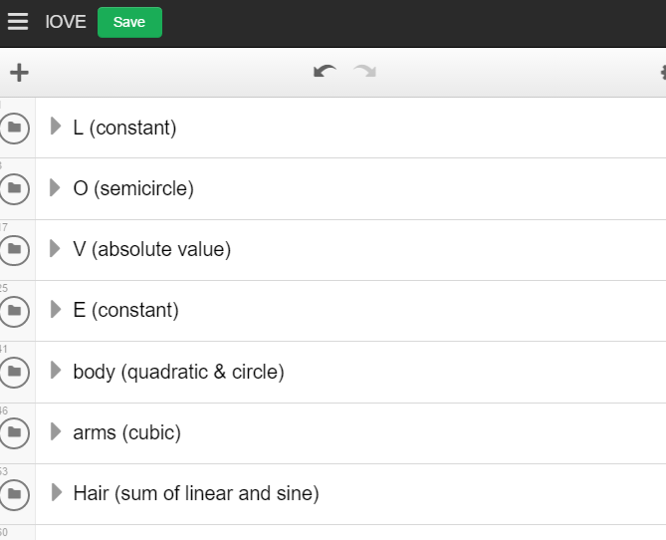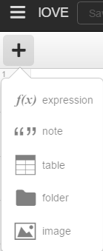
- Each set of equations for a particular body part or letter on your card, must be placed in a separate folder with a title stating what the body part is and the type of equations used. For example above middle is a screen shot of the folders used for the Holiday card created above. To add a folder or a background image click the plus button as shown above right. Your project will not be marked if do not have folders.
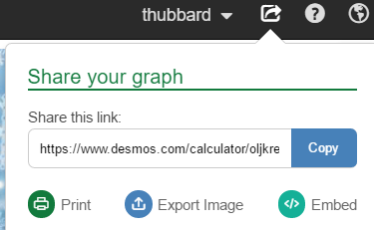
- When you are happy with your portrait and it resembles your uniqueness, screen shot your image and paste it into an Edublog post. Also post a link to the actual desmos page so that anyone reading your post has access to your equations. (Copy the link from the share tab, not from the url)
- In your post write to explain how you figured out what equations to use. Did you have any challenges? Any aha moments? Did you get help? Did you use any strategies? How did this assignment help you understand more about transformations of functions and relations?
Title your post: Desmos Art Functions Card 2018
Tag it: #MathArtPahlevanlu, #creativethinkingcc, #criticalthinkingcc
Categorize it: Pre-Calc 12
- Complete the following self-assessment and include it in your edublog post.
****Link to Desmos File: ______________________________________________
Mark | Process (max. 4 marks) | Score
4 | I clearly described my process, strategies and how I resolved any difficulties, I encountered.
2 | My explanation is somewhat clear.
1 | My explanation lacks detail.
0 | I have not described my problem solving process.
 | Folders (2 marks)
2 | My folders are clearly labelled with body parts and types of functions used
0 | I did not use folders
 | Self-Portrait (max. 4 marks)
4 | My self-portrait resembles my uniqueness
2 | My self-portrait is starting to look like a person
1 | My self-portrait is missing or incomplete
 | Holiday Card (max. 4 marks)
4 | My card has an obvious holiday theme. Color and shading was used to enhance the picture.
2 | My card is starting to look like a holiday card.
1 | No thought was put into the use of color, shading or holiday theme.
 | Equations (max 6 marks)
6 | I used all 6 types of function required
x | I used only x of the required types
 | Function notation (max 10 marks)
10 | I made excellent use of function notation in order to transform the same function repeatedly
5 | I used function notation a few times in order to transform the same function repeatedly.
0 | I wrote new equations every single time and did not use function notation.
 | Creativity and Complexity of Equations (max 10 marks)
10 | My equations show complexity and creativity. I used multiple transformations. (Stretches, Reflections, Translations). I made excellent use of domain and range restrictions.
6 | I used mostly the same type of functions, with some transformations. My functions sometimes overlap because I could not figure out the correct domain and range.
3 | My equations lack complexity and creativity.
Total mark:
(40)
Include any necessary comments or explanations:

