1. Solve the triangle.

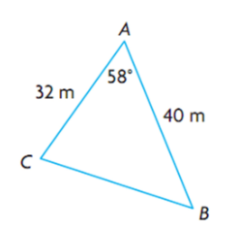

1. Find the length of the indicated side to the nearest tenth.

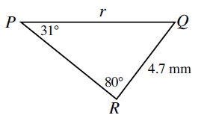

1. 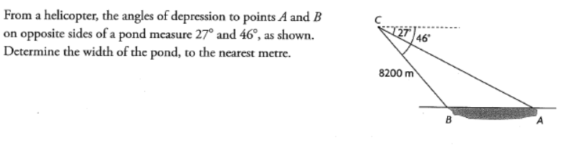 From a helicopter, the angles of depression to points A and B to opposite sides of a pond measure  and . Determine the width of the pond, to the nearest metre.

