5.4 Normal distribution

Data that, when graphed as a histogram, results in a unimodal (one mode, one peak) symmetric distribution about the mean.

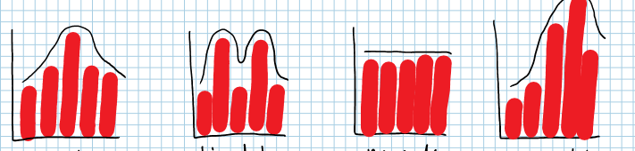

**Example:** Determine if the data is “normal”

|  |  |  |  |  |  |  |  |
| --- | --- | --- | --- | --- | --- | --- | --- |
| Value | Frequency |  | Value | Frequency |  | Value | frequency |
| 10 | 2 |  | 60 | 20 |  | A | 8 |
| 11 | 4 |  | 85 | 42 |  | B | 13 |
| 12 | 6 |  | 100 | 19 |  | C+ | 4 |
| 13 | 5 |  | 115 | 38 |  | C | 3 |
| 14 | 2 |  | 130 | 18 |  | C- | 1 |
|  |  |  |  |  |  | F | 1 |

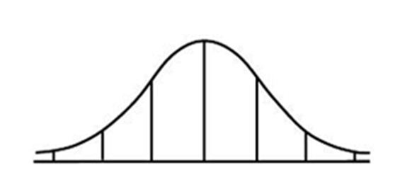

Normal Curve

 = mean

= standard deviation

Sketch the following normal distribution information for the 2 classes on one diagram.

**Example**: Class A =20 and =2 Class B =22 and =2

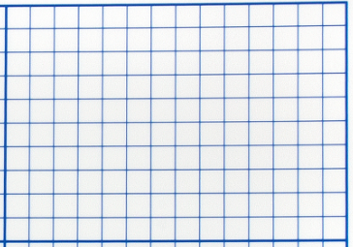

Example: Class A  = 20 and sigma = 4 Class B = 24 and sigma = 2



**Example**: the average life expectancy of a male Canadian is 80 years with a standard deviation of 5 years. Draw a normal distribution for the data.



1. What percent of the males will live to between 75 – 85 years?
2. What percent of the males will live less than 75 years?