**Review: Solve** the given triangle:



*30*

*25o*



Sketch the triangle with the given measurements: ,  and .



Cosine Law:

Rewrite for other sides:

For :

**Example 2**: Find  given that 

**Example 3:** Find the length, to the nearest tenth of a cm, of the third side of Δ PQR if   
QP = 3.1cm, QR = 1.7 cm and ∠ PQR = 110ᵒ.

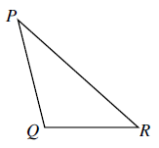

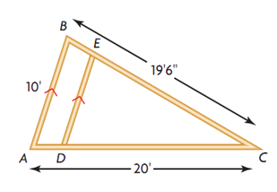**Example 4:** The diagram shows the plan for a roof, with support beam DE parallel to AB. The local building code requires the angle formed at the peak of a roof to fall within a range of 70ᵒ to 80ᵒ so that snow and ice will not build up. Will this pass the local building code?