3.2 – Sine Law in Acute Triangle
Labelling of acute triangles:

Looking at an acute triangle. Can you see two right triangles inside?

Ex 1. What does the triangle look like that corresponds to this equation?
$$\frac{a}{sin⁡(70°)}=\frac{15}{sin⁡(45°)}$$

Ex 2. Determine the measure of ∠ACB to the nearest degree.
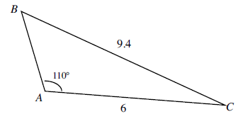

Ex 3. A surveyor measures a base line PQ 440m long. He takes measurements of a landmark R from P and Q, and finds that ∠ QPR = 46ᵒ and ∠ PQR = 75ᵒ. Draw a diagram and calculate the perimeter of ΔPQR to the nearest metre.

