Exploring Parallel Line (2.1)

Review

Acute angle: Angles in a triangle add up to _____

Obtuse angle:

How to label an angle:

|  |  |
| --- | --- |
| Right Triangle | Complimentary & Supplementary Angles |
| Vertically Opposite Angles | Angles at a Point |
| Parallel & Perpendicular Lines | Transversal |
| When there are a pair of parallel lines and a transversal line, the following rules apply: | |
| Alternate Interior Angles | Alternate Exterior Angles |
| Corresponding Angles | Interior Angles |

Using the rules above, you can determine the measures of missing angles in a diagram. Justifications (ie. The rules above) must be given when you determine a missing angle to show *how/why* you know it.

Example 1.

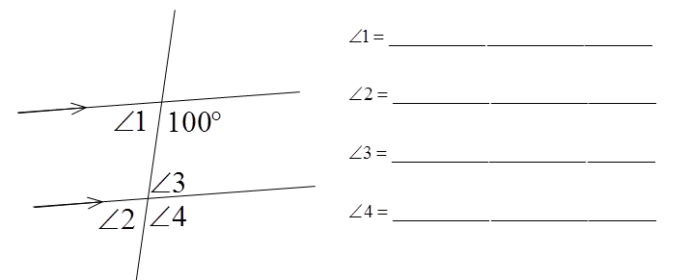

Example 2.



For many of the rules above (corres. angles, alt. int. angles etc) they are only true IF the two lines are _______________.  
The opposite statement *also* works. For example,

If two alternate interior angles are equal, then I know that the two lines are parallel.

Example 3. Is AB || CD? Explain.



Example 4. Are lines AB and DC || to each other?

