1. Which pairs of angles are equal in this diagram?

|  |  |
| --- | --- |
| a. | *a* = *b*, *c* = *d*, and *e* = *f* |
| b. | *a* = *e*, *c* = *g*, and *b* = *f* |
| c. | *a* = *c,* *e* = *g*, and *f* = *h* |
| d. | *a* = *e*, *b* = *d*, and *c* = *g* |

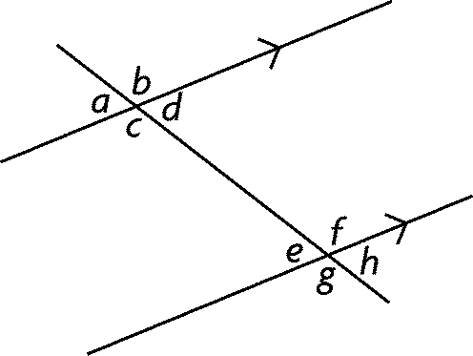

2. Which are the correct measures for *YXZ* and *XZY*?

|  |  |
| --- | --- |
| a. | *YXZ* = 63°, *XZY* = 91° |
| b. | *YXZ* = 53°, *XZY* = 91° |
| c. | *YXZ* = 63°, *XZY* = 81° |
| d. | *YXZ* = 53°, *XZY* = 81° |

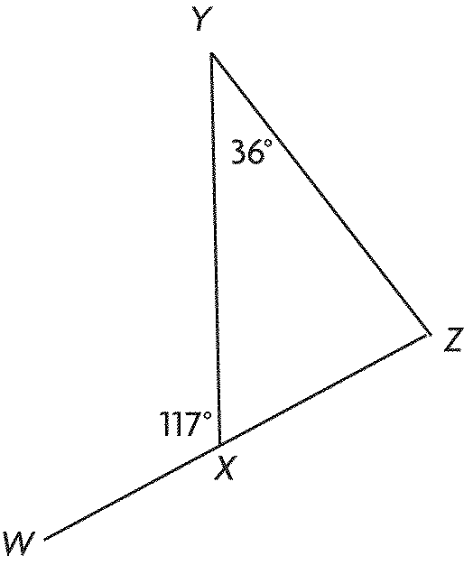

3. Determine the sum of the measures of the interior angles of this polygon.

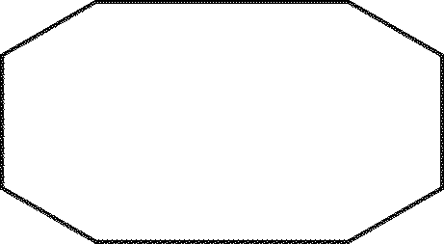

|  |  |
| --- | --- |
| a. | 1080° |
| b. | 1440° |
| c. | 720° |
| d. | 540° |

4. Which are the correct measures of the interior angles of *CDE*?

|  |  |
| --- | --- |
| a. | *DCE* = 46°, *CDE* = 101°, and *CED* = 33° |
| b. | *DCE* = 32°, *CDE* = 83°, and *CED* = 65° |
| c. | *DCE* = 76°, *CDE* = 91°, and *CED* = 13° |
| d. | *DCE* = 56°, *CDE* = 101°, and *CED* = 23° |

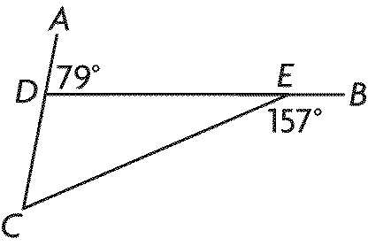

10. Determine the measure of each angle, give reason.

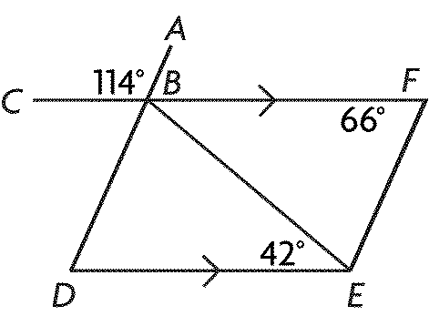

FBE = ____ ______________

FBD = ____ ______________

BDE = ____ ______________

11. Using the given triangle, determine all of the interior and exterior angles



12. Determine the unknown angles.

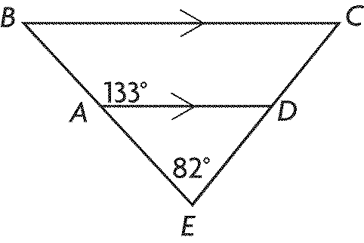

    EAD = ____ _____________

ABC = ____ _______________

ADE   ____ _______________

BCD = ____ _______________

CDA = ____ _______________

13. Determine the value of *x*.

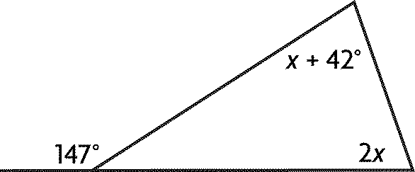

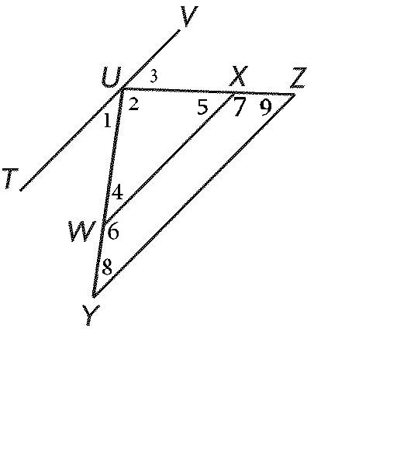

14. Given: UY = UZ.

8 = 5

Prove: WX || YZ